Review of the science and technology behind continuous ink jet printing

**Edition 1.1 - April 2016**

This review offers a guide to new starters in Domino’s Marking Materials Department, as well as a reference guide for existing members. An introduction to continuous inkjet printing is given which is followed by discussions of the physics and chemistry relevant to inkjet printing in addition to Domino’s current technology.

Additions to this text are planned to broaden its scope as such this will be a periodically reviewed document. Any reader’s comments are welcomed in order to help improve and expand this text.

**Summary of Change History**

|  |  |  |  |
| --- | --- | --- | --- |
| Alfresco Version | Author | Approval Date | Description |
| 1.0 | J M Philpott |  | First edition |
| 1.1 | J M Philpott  A Kyriacou |  | First edition with extra case study |

**File location: \\dps.local\group\Domino\RandD\Live\Functions\MarkingMaterials\Library\Review of the science and technology behind CIJ**

**This is a Domino Printing Sciences internal document, its contents are confidential and should not be distributed outside of Domino.**

Table of Contents

1. Introduction 3

2. The physics of Continuous Ink Jet Printing 5

2.1 Surface tension 5

2.1.1 Spherical drops 5

2.1.2 Drops on surfaces 6

2.1.3 Pressure in drops 6

2.1.4 Capillary action 7

2.1.5 Dynamic surface tension 7

2.2 Viscosity 8

2.2.1 Viscoelastic, Newtonian and non-Newtonian fluids 8

2.2.2 Measurement of Viscosity 10

2.3 Jetting and drop formation 10

2.3.1 Jet break‑up 10

2.3.2 Satellites, micro-satellites and non-main drop objects 11

2.3.3 The jet environment 12

2.3.4 Drop charging 12

2.3.5 Drop deflection 12

3. Domino’s CIJ technology 13

3.1 Printer anatomy 15

3.1.1 Printhead 15

3.1.2 Ink management 16

3.2 Printer function 18

3.2.1 Drop phasing 18

3.2.2 Raster and matrices 20

4. The importance of dimensionless numbers 21

5. Chemistry of Inkjet inks 23

5.1 Surfactants 25

5.2 Polymers in solution 28

5.3 Colloids 30

5.3.1 Colloid instability 31

5.3.2 DLVO theory - attractions, repulsions and Zeta potentials 31

5.3.3 Steric stabilisation 34

5.3.4 Depletion and bridging flocculation 35

5.3.5 Stokes separation 36

5.3.6 Repercussions for pigmented inks 36

6. Appendices 37

6.1 Ink management systems 37

6.2 Other training documents 38

6.2.1 Theory of ink jet training module 38

6.2.2 Viscosity Dependent Printhead Functions 2.0 38

7. References 38

# Introduction

Inkjet technology was originally developed by Sweet[1] to replace moving-pen or -stylus recorders (like those still found on seismographs and tachographs today) for recording the amplitude of a signal on paper.1 In this report ink was forced through a circular 35 *µ*m nozzle under pressure, producing a jet of ink that broke-up from a column of ink into regularly spaced ink drops, which were formed at a rate of 100,000 s‑1 (Figure 1). This regular break-up was induced by vibrating the nozzle to create instabilities in the jet that would cause break-up. A metal plate located around where the jet break‑up occurred induced electrical charging of the drops dependent on the amplitude of an input signal. Thus, a stream of drops with varying levels of charge was created. When passed through a pair of deflector plates held at a fixed potential difference (voltage), the drops deflected according to the charge on the drop and then impacted on a moving paper substrate, creating a trace of the input signal.

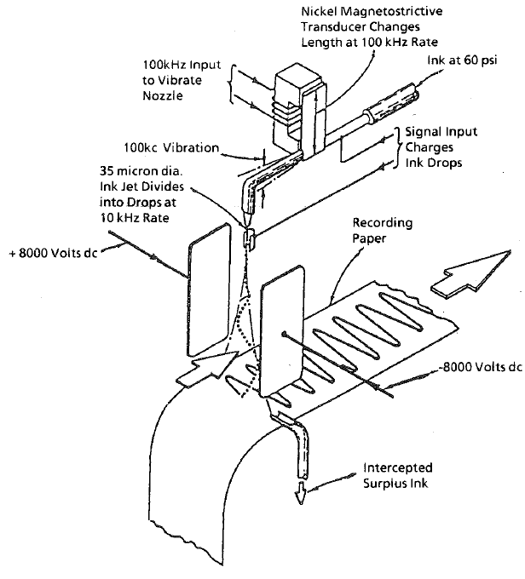

Figure . Sweet’s InkJet Oscillograph. Ink is pumped through the printer nozzle at 60 psi from an ink reservoir, the resultant jet of fluid is induced to break‑up at 100 kHz by nozzle vibrations. The drops break‑off within a charge electrode, connected to the input signal, that dictates the charge placed on each drop. Finally, fixed voltage deflector plates deflect the drops that are then printed onto the moving substrate and surplus ink is removed by a gutter.

Three modifications to Sweet’s oscillograph produce the basic technology for modern continuous ink jet, CIJ, printers (Figure 2). The first is the repositioning of the gutter so that drops with little or no charge are caught and recycled through the printer – only charged and deflected drops are printed onto the substrate. The second is the inclusion of a piezoelectric ceramic into the drop generator in the print head that vibrates a drive rod to introduce a sinusoidal surface wave on the jet that leads to regular break‑up, replacing the nickel transducer. The third is the ability to digitally address single drops with the input signal using phasing controls to calibrate the signal timing, in other words, charge can be placed on one drop to cause it to deflect and print whilst those around it are not charged and fall in the gutter. This is no easy task considering the frequency of the drop formation (between 64 and 104 kHz).

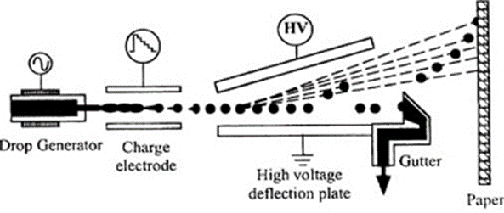

Figure . Simplified schematic of a modern CIJ printhead, a pump and filter system feed the drop generator and the gutter collects unprinted ink for recycling in the printer. Reproduced from reference.2 For context with a Domino printer watch [video](https://www.youtube.com/watch?v=99Jz2JFmp1c).3

Currently Domino’s CIJ printers are used to mark and code a large range of products, these codes are used to fulfil internal and regulatory demands on traceability of manufacture. Typically these codes are alphanumeric marks that state a date (and time) and location of manufacture of the product that need to be reliably printed on a variety of substrates (inc. metal, glass, plastics and eggs) at high speed. CIJ is favoured for the relatively low cost of printing, high speeds (can keep up with the production line) and ease of managing and changing the code (each product can be uniquely marked from an automatic coder).

Ink is a vehicle that allows the placement of coloured code onto a solid substrate, fountain pen inks were initially used for the oscillographs and early printers, these are aqueous inks that carry a water‑soluble dye alongside surfactants and natural resins.4 These inks provided adequate performance for black printing on paper substrates, however, modern demands on CIJ inks are significantly greater and more diverse. There are three major groups of demands that modern CIJ inks must meet in order to be commercially viable, they are:

1. End user properties. The ink must print and dry onto the desired substrate, providing a permanent and resolvable code that can be printed at, or faster than, the production speed of the product. Therefore the printed code must provide: appropriate colour and optical density, colour fastness, high print quality, adhesion, abrasion and offset resistance and solvent resistance.
2. Jetablilty and printability. Appropriate fluid characteristics must be achieved in order to provide the physical properties that allow an ink to flow through the printer, be sufficiently charged for deflection, produce a jet that breaks‑up within the charged electrode, produce a regular stream of ink drops of consistent size, avoid solid deposition within the print head, and produce a round dot of colour when contacting the substrate. Surface tension, viscosity, density and conductivity are key for printability and can be compared by a series of dimensionless numbers, expanded upon below.
3. Stability. The ink must have a reasonable shelf-life that allows for the above two criteria to be maintained as well as stable changes in temperature, humidity, dissolved water, *et c.* experienced during printing on production lines.

It is the formulator’s job to meet these demands by means of altering the chemical composition of the ink and proving, by means of testing, that the demands have been met. Additionally cost of manufacture, regulatory and commercial concerns must also be considered and met. This document aims to provide ink chemists with relevant background information on the science and technology of CIJ printing, as well as Domino‑specific knowledge on the challenges and problems faced by chemists and means to meet these challenges.

# The physics of Continuous Ink Jet Printing

This section will review macroscopic fluid properties and physical processes that are relevant to CIJ printer function. Of the following concepts, some have immediate and direct importance to a formulating chemist, while others have a more indirect impact on formulation but are nonetheless important considerations, especially for ink systems that present challenges with printer performance.

## Surface tension

### Spherical drops

Surface tension is the phenomenon that will induce a water drop in air to take a spherical shape, this is because the energy of the interface between a liquid and gas is greater (less favourable) than that of the energy of the liquid bulk (Figure 3). In other words, a greater number of positive intermolecular contacts can be made in the denser water bulk than between water molecules at an interface to the less dense gas. In this case the cohesive forces, which are working to increase the number of water-water interactions, dominate the adhesive forces, which are working to increasing the number of water-air interactions. Therefore the lowest energy shape that the water could adopt is a sphere, which has the lowest surface area : volume ratio *i.e.* the smallest air-water interface.[2]

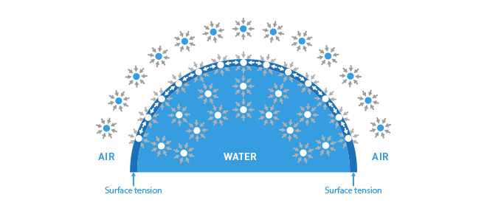

Figure . Surface tension acts to reduce the surface area of liquid-air interfaces, because the energy of the molecules at the interface is higher than those in the bulk due to a lower number of intermolecular interactions.

Mathematically, increasing the surface area, ***σ***, of a fluid requires work, ***w***, to be done. The work needed is proportional to the increase in surface area times a constant of proportionality, so we write,

$dw=γdσ$ (1)

where surface tension, ***γ***, is the constant of proportionality; a greater surface tension means more work is required to increase the surface area of a fluid interface, or more energy is produce by reducing the surface area. Surface tension has dimensions of energy/area but we normally use units of N m-1 (1 J ≡ 1 N m, 1 J m-2 ≡ 1 N m-1). 

It should be noted that surface tension is temperature dependant and that the surface tension is determined by both interfacing media. The surface tension of water is not a constant but the surface tension of water in air is constant (at a given temperature and pressure).

### Drops on surfaces

Surface tension will drive ink in air to form a sphere at equilibrium, when an ink drop is in contact with more than one medium the drop shape is dictated by the balance of different surface tensions from the different interfaces (Figure 4). Considering an ink drop on a solid, there are three interfacial tensions that need to be balanced, the solid-liquid, solid-air and liquid-air surface tensions (sometimes termed surface free energies, but remember this is an energy per area). If the surface tensions are not balanced they induce a force that works to achieve equilibrium.

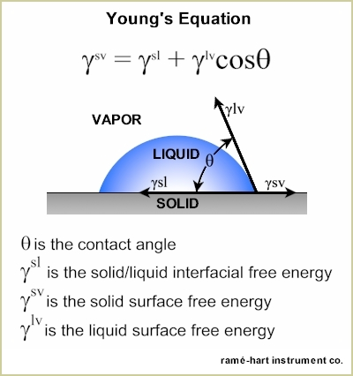

Figure . Demonstration of contact angle measurement according to the Young’s Equation.

At equilibrium the contact angle between the solid and the liquid provides a measure of how far a single drop will spread over the surface of the solid, *i. e.* the wettability of the surface by the fluid, as well as being crucial for equating the three surface tensions using the following equation,

$γ^{sv}=γ^{sl}+γ^{lv}cosθ$ (2)

where ***γsv***, ***γsl*** and ***γlv*** are the solid-vapour, solid-liquid and liquid-vapour surface tensions, respectively and **θ** is the contact angle. The contact angle is the angle that the surface of the liquid subtends where the liquid meets the solid (smaller contact angle, greater wettability). Furthermore, the wettability of a system dictates the diameter of a spot created by a printed drop as the balance of surface tensions dictate how far a drop will spread.

### Pressure in drops

Surface tension generates a pressure within the liquid, much like balloon generates pressure in the air inside. This pressure is proportional to the surface tension and the curvature of the interface, high surface tensions or high curvatures generate high pressures, this is described by the Young-Laplace equation,

$Δp=2γH=γ\left(\frac{1}{R_{1}}+\frac{1}{R_{2}}\right)$ (3)

where ***Δp*** is the pressure difference between across the interface, ***H*** is the mean curvature and ***R1*** and ***R2***are the radii of curvature (bigger values of these ≡ lower curvature). For example, ***Δp*** = 800 Pa for a 120 *µ*m diameter drop of butanone (MEK), whereas, ***Δp*** = 9600 Pa for a 10 *µ*m diameter drop of butanone.

### Capillary action

Surface tension is also responsible for capillary action, the phenomenon by which liquids can flow through narrow spaces (≤ cm) without, or against, external forces such as gravity or air pressure. For example, if a glass capillary is placed in water, the water will rise through the capillary against gravity, as the water attempts to coat the glass. Capillary action also causes ink to bleed or wick into porous substrates, as the pores act as capillaries and the liquid attempts to increase contact with the solid (whilst decreasing contact with air or vapour).

### Dynamic surface tension

It was stated earlier that “surface tension is a constant of proportionality” and “surface tension of water in air is constant”, this holds true for pure liquids, however, if the liquid contains surfactants (introduced later) then the liquid may have a dynamic surface tension that is not constant at newly created interfaces (Figure 5). This is because a newly created interface is a non-equilibrium state in which the solutes will not have time to adjust to the change. Surfactants act to reduce surface tension by ordering at interfaces and lowing the interfacial energy, but as solutes they are diffusion rate limited so they need time diffuse, collect and order at the interface. Therefore, situations arise where surface tension of a newly created interface will lower over time as surfactants diffuse from the bulk to the interface. Furthermore, solutions with expanding interfaces may deplete the amount of surfactant present at the interface, increasing surface tension. In addition, surfactants may be deposited onto solid surfaces by motion of the liquid through or along solid interfaces depleting surfactant concentrations.

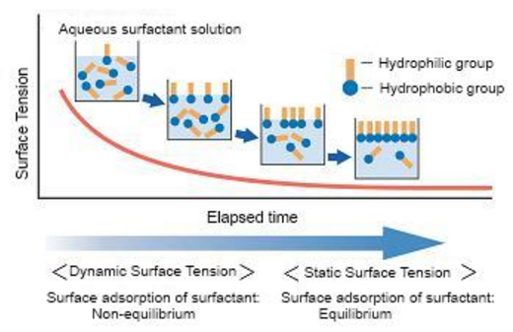

Figure . Illustration of dynamic surface tension which is dependent on the kinetics of surfactant diffusion and non-equilibrium surfactant distribution. For estimation of the time scales of this process follow [this link](http://www.stevenabbott.co.uk/practical-surfactants/dst.php). Figure reproduced from.5

With context to CIJ printing, a jet of ink leaving a nozzle at high speed will likely demonstrate dynamic surface tension as surfactants present have to diffuse to the newly created liquid-air interface before the surface tension is lowered. The result is a relatively high surface tension for the initial jet that lowers with time.

## Viscosity

To most chemists viscosity is a familiar concept but it is an intricate subject and can be a challenging physical property to control in formulations. Formally, viscosity is a measure of the resistive response of a fluid to an applied shear stress that results in an irreversible deformation. To use an example of a stirring rod in a beaker of water, stirring the water causes a shear stress as there is a differential flow across the water (flow is zero at the stirring rod and the beaker’s walls but the fluid close to the rod moves fastest, and past other areas of the water, so water moves past water). Once moved or deformed by the stirring rod the water does not return to the initial state, demonstrating an irreversible response; as opposed to a reversible elastic response where the fluid or solid would return to the initial state (*e. g.* a rubber band after stretching). In this process energy is dissipated to the water, not as motion with the stirring rod but as a force that opposes, or resits, the stirring action – the greater this resistance the greater the fluid viscosity.

As a warning, there are a number of different viscosities that can be measured and reported, the viscosity described above is dynamic viscosity. The other two commonly used viscosities are kinematic viscosity, which is the ratio of dynamic viscosity to density, and bulk viscosity which is the response of a fluid to a non-shear compressional or expansional force. Dynamic viscosity can also be heavily temperature dependant and measurement of viscosity need to be carefully temperature controlled. Typically, viscosity is measured in cP (centi poise) or the equivalent mPa s (milli pascal seconds).

Water, hexane, butanone, glass and pitch can all be thought of as viscous fluids and all have a measurable viscosity at room temperature. Under the influence of gravity all will flow downwards under shear conditions, the famous examples of slow flow/high viscosity fluids are glass measured bulging in church windows and the pitch-drop experiment,**6** which is the longest running chemical experiment in which one piece of pitch has been observed flowing through a glass funnel since 1927 (Figure 6).

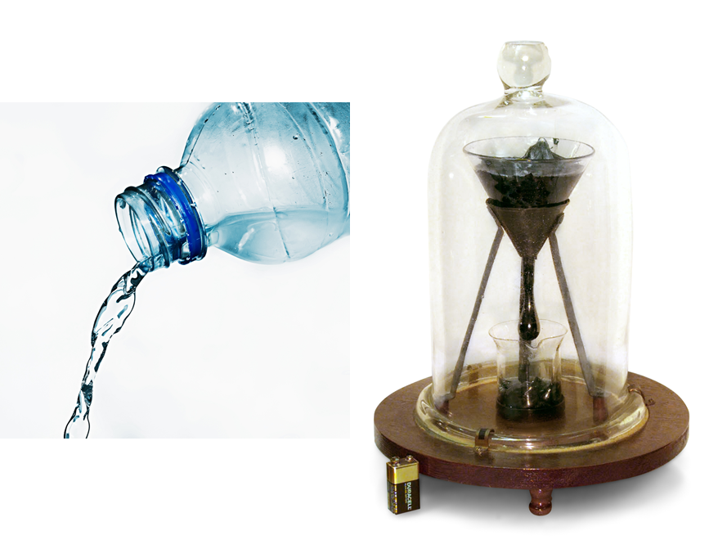

Figure . Both water and pitch flow at room temperature, but at very different rates according to their viscosity. Typical viscosities at 25 OC are as follows: water 0.89 cP, CIJ inks 3-7 cP and pitch 2 x1011 cP.6

### Viscoelastic, Newtonian and non-Newtonian fluids

In addition to resistance to irreversible deformation (viscosity), resistance to reversible deformation (elasticity) can also be demonstrated by fluids. If both are exhibited by a fluid then it is termed viscoelastic, gels are a good example of a viscoelastic fluid and upon shear will return, or partially return, to its initial structure. Viscoelastic behaviour should not be confused with non‑Newtonian behaviour, they are separable phenomena.

Fluids that demonstrate shear rate independent dynamic viscosity are termed Newtonian, whereas, if a fluid’s viscosity varies with shear rate then it is termed non‑Newtonian. For Newtonian fluids viscosity is the constant of proportionality that relates shear rate to the shear stress, this is not true for non-Newtonian fluids where viscosity is a function of both temperature and shear rate (Figure 7). Here four types of non-Newtonian fluids are introduced,

1) Shear thinning fluids (pseudoplastic). Higher shear rates result in a reduction of fluid viscosity, most commonly associated with polymer solutions where a significant component of viscosity is the overlap of polymer chains increasing the resistance to flow. At higher shear rates the polymer coils are extended and become aligned so they flow past one another more readily, which manifests as a drop in viscosity.

2) Shear thickening fluids (dilatant). Higher shear rates result in an increase of fluid viscosity, commonly demonstrated with cornstarch in water (“[running on custard](https://www.youtube.com/watch?v=BN2D5y-AxIY)”). In this case, the cornstarch particles in solution are discrete and flow past each other at low shear rates, at higher shear rates flocculation of the particles is induced, networks of particles are generated and fluid becomes more solid.

3) Thixotropic fluids. These fluids become less viscous over time when stressed, so have a viscosity that is dependent on shear duration rather than shear rate. Pseudoplastic fluids are commonly also thixotropic, therefore, if a fluid is demonstrating shear thinning behaviour, it is worth maintaining a constant shear rate and observing if there is a further reduction in viscosity according to time, if so the material is also thixotropic. Thixotropicty results if the time scale for response to shear is slow meaning an equilibrium flow response is not reached at the rate of the shear increase. Flocculated particle dispersions, like settled ink, can display this behaviour.

4) Rheopectic fluids. Possibly the least common of the four discussed, this is time dependant viscosity increase under shear conditions.

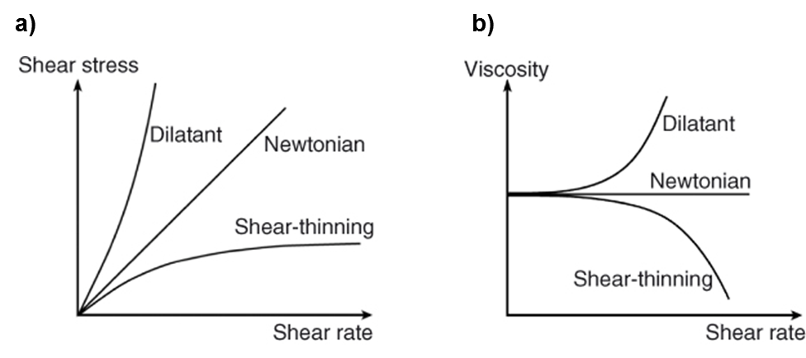

Figure . Exemplar plots of Newtonian, shear-thinning and shear-thickening materials.

In terms of flow an ink in a CIJ printer will experience some extreme flow regimes, high pressures in the gear pumps, and very high shear rates (up to 1,000,000 s-1) at the nozzle, that are not typically measured by analytical techniques. Therefore if inks display non‑Newtonian behaviour at high shear rates their viscous response can be very hard to predict and highly variable.

### Measurement of Viscosity

Accurate measurement of viscosity at low shear is possible with a simple rotor with known drive force and measuring the resultant speed of spindle, the Brookfield viscometers. Higher sheer experiments require more sophisticated equipment, currently at Domino the Anton-Parr Rheometer and Malvern Instruments m-VROC are appropriate for measurement and analysis of non-Newtonian behaviour. For more information refer to reference.7

## Jetting and drop formation

Here a jet is defined as a column of fluid that traverses with a greater momentum through another fluid, in the CIJ case an ink column moving through air. As described earlier, a jet breaks‑up into drops which allows the generation of discrete packets of ink (drops) with which to print.

### Jet break‑up

All fluid jets are inherently unstable and liable to break‑up into drops (Figure 8), this is because multiple Plateau-Rayleigh instabilities are present in a jet. The instability with the greatest growth rate will dominate, and as an instability dominates it creates a sinusoidal ripple down the length of the jet which, when the amplitude of the wave is greater than the diameter of the jet, generates drops that break off from the continuous stream. The growth rate of these instabilities is observed to be exponential with time.

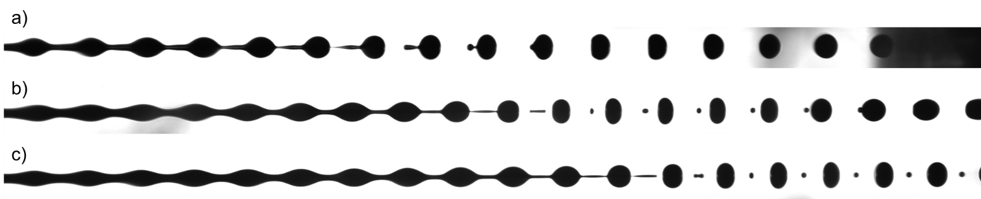

Figure . Images of jet break-up in a CIJ printer, showing jet break-up to form main drops (a); main drops and satellites that recombine with the main drop (b) and main drops with persistent satellites (c).

The growth of the instabilities is driven by surface tension which exerts a force to reduce the surface area of the jet. In an ideal column of fluid, surface tension exerts an equal pressure on the sides of the jet, the instabilities vary the diameter along the jet’s length, therefore the curvature generated takes the form of a sinusoid and produces differential pressures along the jet. In effect, narrow parts of the jet are driven narrower due to their greater curvature (see the Young-Laplace equation above) which eventually leads to the point of zero diameter and therefore detachment from the ink jet. As fluid breaks‑off from the jet, surface tension is still acting to reduce surface area and draws the fluid into spheres. In an ideal CIJ scenario all the broken‑off fluid gathers into a single drop, however it is possible that smaller drops are created following the main drop, termed satellites. These are discussed below.

Whilst surface tension induces a force to enhance the instabilities in the jet and cause break‑up, density provides an inertia to retard the rate of break‑up and viscosity provides a resistive response to the shear flow caused by the propagation of the sinusoidal instabilities. Therefore, high surface tension leads to faster break‑up; high density leads to slower break‑up; and high viscosity leads to slower break‑up.

The frequency, ***λ***, and spacing of the drops is determined by the diameter of the jet, ***d***, and the growth rate of the instabilities (which in turn is determined by surface tension, viscosity and density). For inviscid fluids the growth rate, ***α***, is maximum for the condition *λ* = 4.51 *d* (Figure 9), for viscous fluids this value increases to near 6 *d* but for the viscosities relevant to CIJ inks *λ* = 4.51 *d* is a good approximation.8 This is of importance because the pressure in the ink jet is deliberately oscillated in a printhead, by a piezo device, to resonant the desired instability and reliably generate break‑up. It follows that resonating the instability with a frequency that fulfils the *λ* = 4.51 *d* condition results in the fastest and most efficient jetting behaviour.

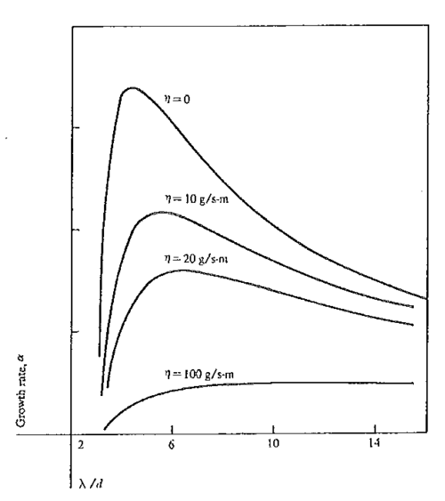

Figure . Dependence of instability growth rate, *α*, on *λ/d* and viscosity for liquid jets. For inviscid fluids maximum instability growth rate is achieved when drops are formed at a wavelength of 4.51 times the dimeter of the jet. This growth rate is lowered with increasing viscosity, and *λ* for *α*max increases.8

### Satellites, micro-satellites and non-main drop objects

In the ideal situation for CIJ printing a jet will neatly break‑up to produce a series of evenly spaced and sized spherical drops. The frequency of these drops is that of the applied pressure oscillation and the diameter (and therefore volume) of the drops can be calculated using,

$d_{d}=\sqrt[3]{\frac{3}{2}{d_{n}}^{2} λ}$ (4)

where ***dd*** is the drop diameter, ***dn*** is the nozzle diameter and ***λ*** is the frequency.

The point at which a discrete drop detaches from the continuous jet is known as the break‑off or pinch‑off point, typically either side of the break‑off point a ligament is formed and then is quickly retracted into the new drop which is taking a spherical shape, or into the following jet (Figure 8 a). In a non‑ideal break‑up situation there can be multiple break‑off points between the main drop and the jet, this produces a thin filament which forms one or more smaller drops, termed satellites (Figure 8 b,c). Depending on break‑off order and momentum of the system these satellites can:

1) Catch up to and recombine with the main drop, this occurs when break‑off happens closer to the jet first and the ligament is accelerated towards the drop by surface tension, before the second break‑off occurs (Figure 8 b).

2) Carry a very similar velocity to the main drop and remain in between two main drops (Figure 8 c).

3) Move with a lower velocity than the ink stream and combine with the jet or proceeding drop, this occurs in the opposite situation to 1.

All of these situations can reduce print quality or printability of an ink. This reduction in printability can be caused by errors in charging, where a main drop carries a spurious charge/mass ratio and therefore is not deflected as intended by the deflection plates (see below) due to charge being carried on satellites and variations in drop mass.

In addition, there are hypotheses that matter too small to be imaged by current technology can be generated by certain break‑up regimes. This matter may hinder intended deflection and/or deposit and build‑up inside the printhead. The various hypotheses state that this matter could take the form of micro-satellites, liquid aerosols or solid aerosols which could be generated by regular or random events in jet break‑up. This is currently under investigation.

### The jet environment

The ink stream traveling through air will generate an associated air stream and air currents, typically the stream is traveling at ≈21 m s-1 (76 km h-1) through the confined space of the printhead. This has two significant consequences, the first is that any drops that are deflected outside of the ink stream decelerate significantly faster than those in the steam because it has been removed from the slip stream and moving air generated by preceding drops. Drops deflected in sequence can also alter each other’s courses by generating air currents outside the main ink stream, this can be corrected for in the raster (section 3.2.2). The second consequence is that the ink stream is likely to entrain particulates and mist due to the lowered air pressure caused by having a fast moving air stream and is of significance to the transport of the hypothesised micro‑satellites and aerosols.

### Drop charging

Efficient and accurate drop charging is of great importance to ensure that drops are deflected to the desired place on the substrate. The ink jet is connected to earth and the potential difference applied to the charge electrode induces charging of the jet, the charge carried on the jet at break‑off is then retained by the drop as it becomes isolated in the air. Note that the charge electrode is isolated from the ink stream, its only influence is a capacitive one that repels like charges and attracts opposite charge into the jet. In Domino’s A‑series printers a negative charge is induced on the drops by a positively charged electrode.

The charging rate is dictated by the conductivity of the ink and the total potential difference between the jet tip and its environment. Remember that drop formation is occurring at a minimum rate of 64 kHz, or once every 15.6 x10-6s, and that any drops that are to printed need to be specifically charged in less than this time and typically with a different charge to drops around it. Therefore, the ink conductivity needs to be high enough that it does not hinder charging rates at these timescales, and that is why conductivity salts are added to ink. From a chemical point of view, we assume that charging occurs by migration of charged species away from a charge balanced state, *i. e.* for charging a drop, anions are attracted to the jet tip and cations are repelled and migrate up the stream. The capacitive charging of the jet is controlled by the charge electrode but it is also effected by the previously generated and charged drops, with the charge of each drop effecting the charging with an inverse square effect according to distance. The printer software must account for this effect in the voltage applied to the charge electrode.

### Drop deflection

After the charged electrode the ink stream travels though deflector plates that are held at a fixed voltage, the resultant electronic field deflects the drops according to the following equation,

$x_{d}=l_{p}\left(\frac{Q_{d}V_{p}}{m_{d}d_{p}{v_{d}}^{2}}\right)\left(z_{p}-\frac{l_{p}}{2}\right)$ (5)

where ***xd*** is the drop displacement away from original path at the length ***zp***, ***lp*** is the length of the deflector plates, ***Qd*** is the charge on the drop, ***Vp*** is the voltage across the plates, ***md*** is the mass of the drop, ***dp*** is the distance between the two plates, ***vd*** is the velocity of the drop. This equation is only valid for a pair of parallel plates, current printhead design does not use a pair of parallel plates, therefore requires trigonometric augmentation. Regardless, the same physical terms are still relevant and the magnitude of drop deflection is dependent on plate voltage and separation, throw distance (how far away the substrate is) and drop charge, mass and velocity. Notably, the velocity function is squared and small variations in jet velocity result in considerable changes to extent of deflection. It is worth remembering that deliberate deflection only occurs in one dimension, it is the (constant) lateral movement of the substrate under the printhead that provides the second dimension that allows for printed code.

As per charging, complications arise due to the interactions between drops, as all drops are positively charged they repulse one another and effect the local electric field, altering velocities and distances of deflection. This is on top of the aerodynamic interactions that occur between drops and the drag stream of preceding drops. Both of these effects need to be addressed and compensated for in the software that drives charging.

# Domino’s CIJ technology

Domino makes and markets multiple ranges of printers, the A-series range consists of continuous inkjet printers and is Domino’s longest running range. Currently the range consists of three sub ranges, the A-series i-Tech, the A‑series Specialist (or plus) and the A‑series GP, in addition there is a planned launch of the new Ax-series in November 2016 (Table 1 and Figure 10).

|  |  |  |  |
| --- | --- | --- | --- |
| Product Names | Brands | Range name | Internal name |
| A100, A200, A300, A400, A300SE | 1. A-Series | A-Series | Originally A-Series but now Classic |
| A100+, A200+, A300+, A300SE+ | 1. A-Series 2. ***plus*** | A-Series ***plus*** | Plus |
| A100GP, A150GP  rebranded  A120, A220 | 1. A-Series 2. GP | A-Series GP | GP |
| A320i, A420i, A520i | 1. A-Series 2. i-Tech | New A-Series then A‑Series i-Tech or Ultima | i-Tech or Ultima |
| Ax150i, Ax350i, Ax550i | 1. Ax-Series | Ax-Series | Ax (project name Galileo) |

Table . Complete list of all CIJ printers made and marketed in the A-series range, the first row are obsolete, the middle three rows are currently on the market, and the last row is currently in development and it is planned that this sub-range will replace the majority of older printers after launch in Nov 2016.

The old GP series is still marketed as it provides sales at the lowest end of the price bracket and is mainly sold through Domino’s distributors. The A‑series Specialist (or Plus) range is still marketed as it provides solutions for difficult environments/inks that are not catered for in the i-Tech range - these include abrasive and ‘heavy opaque’ inks, egg coding, environments with high levels of airborne contaminants and mail and postal systems. The most recent i-Tech range reduces servicing requirements, increases ease of ink and ‘make up’ refil,[3] and improved connectivity with the production line and management systems. Named after the i-Tech modules, this range utilises ink cartridges that contain ink filters and pressure venting capabilities, as well as ease of refill with simple fit top-up cartridges.

The goal of launching the new Ax-series is to provide a market leading printer with low cost of ownership, high performing technology and high performing inks. Ink modules will also be monitored by an RFID system that will reduce the risk of users loading incorrect/out‑of‑date or third party inks. In addition, the aim is to eliminate the complexity that has grown into the A­‑series range and provide a clearer product offering. Whilst offering only three printers in the new range (Ax150i, Ax350i, Ax550i), software and hardware upgrades, four different nozzle sizes (40, 50, 60 and 75 *μ*m), four different conduit lengths (links between printer and head) and different head sizes and geometries will be offered for the printers.

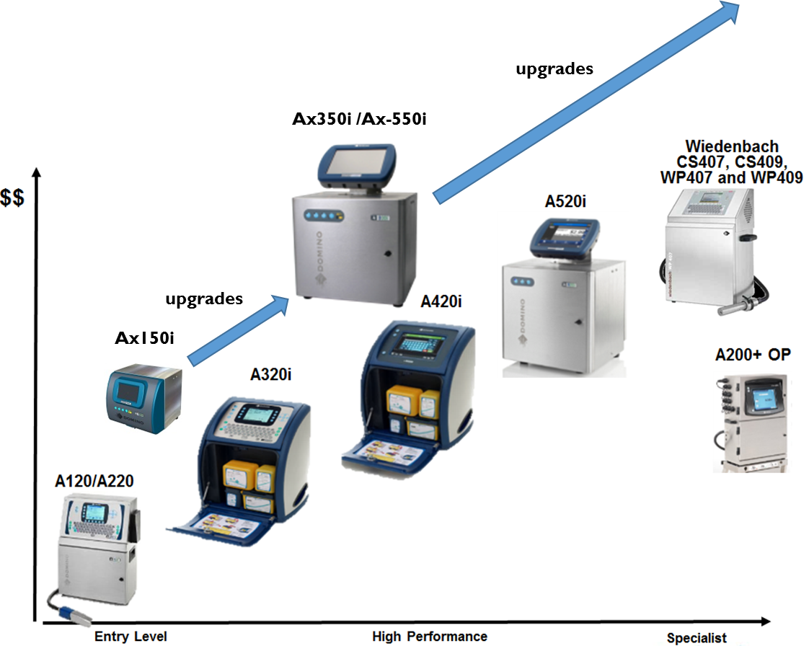

Figure . Sales team schematic of the A-series range with the new Ax series aiming to provide a consolidated product offering with possible upgrades to provide market leading technology.

Domino sold 16,788 A-series printers worldwide in 2014 and once installed printers will tend to be replaced every 5-7 years. With such a large ‘installed based’ of printers aftermarket sales of ink is vital to the CIJ business and justifies significant chemical R&D spending. Creating inks that outperform third party inks for reliability and performance is therefore critical to maintaining strong aftermarket sales and assure income for Domino.

## Printer anatomy

This section aims to introduce the basic anatomy of A-series printers using the latest models as examples, therefore, discussion is not fully generic and older models will differ slightly in design, where possible extra schematics are given in the appendices. The electronic and software systems are also not discussed in this text for the sake of brevity.

### Printhead

The printhead is a vital part of the CIJ printer, attached to the flexible conduit it is positioned in close proximity to the substrate to allow for printing. Within the printhead there is a drop generator that heats the ink (usually to 42 OC)and vibrates the inkjet at the appropriate frequency with a variable amplitude, set by the modulation voltage, which leaves the drop generator *via* the nozzle under the ink pressure (typically 3 bar) (Figure 11). The inkjet then passes through the turret of the charge electrode, the jet must break-up within the turret if it is to be phased, charged and printed. Lower in the charge electrode the drop stream passes through the charge detector.

Once leaving the charge electrode the drop stream will pass between the deflector plates held at a constant, high potential difference to one another where anything charge will be deflected. Drops will then enter the gutter if undeflected or pass through the baseplate and onto the substrate if deflected.

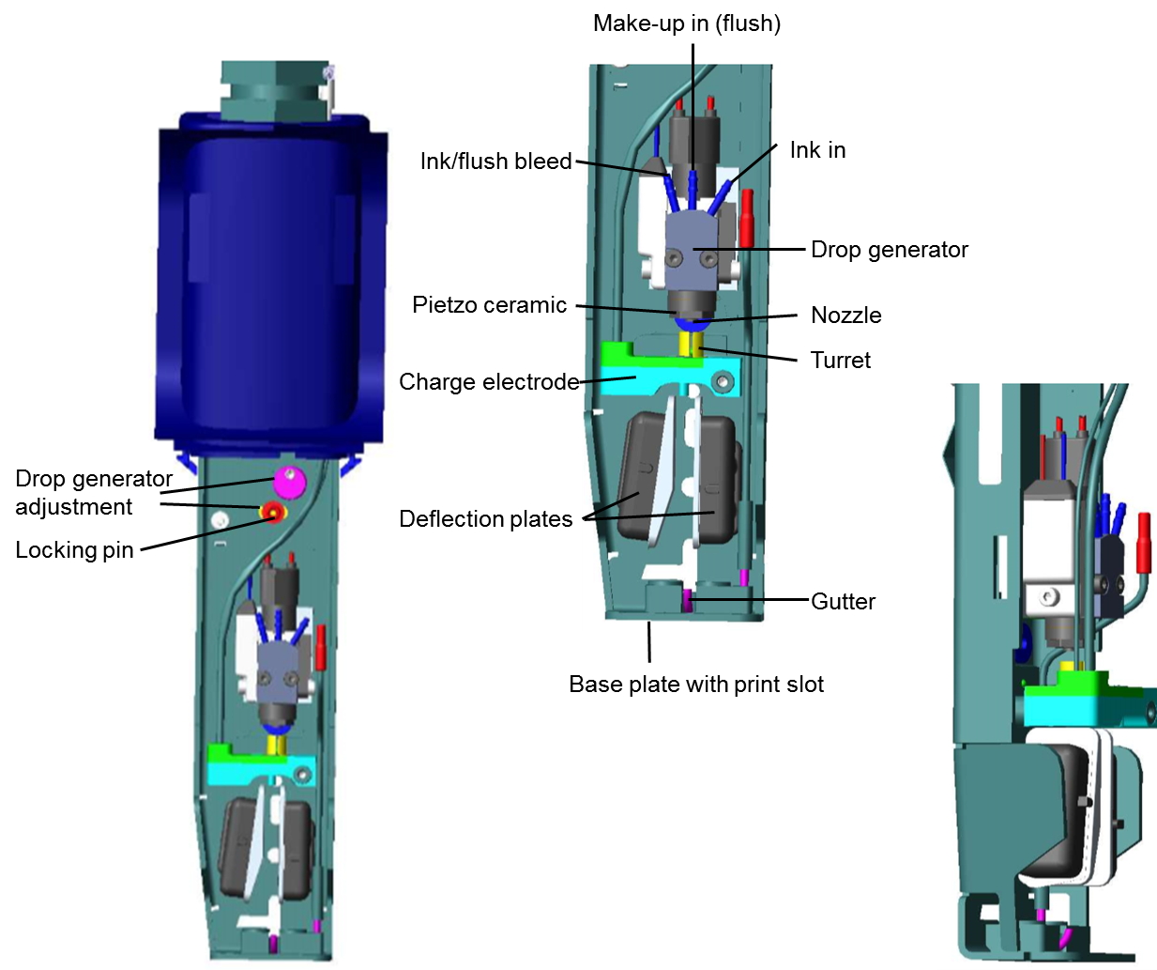

Figure . Annotated images of the latest A-series printhead.

### Ink management

Domino printers have a sophisticated system for managing fluids in order to assure the correct working of the printer, the new Ax-series contains that latest design of ink management system (Figure 12). The ink delivery or feed line (Figure 12 red) delivers ink to the printhead from printing *via* a gear pump, cooler, filter and damper. The gear pump provides the pressure to drive the ink round the system; the cooler attempts to reduce the temperature of the ink to reduce evaporation rates and to deliver ink to the printhead below its operating temperature of 42 OC; the filter attempts to filter out any particulate matter (e. g. dust and contaminants) to prevent nozzle blockage and the damper acts to reduce pressure variations in the ink line. So called ‘opaque’ or ‘pigmented’ inks - inks that contain colloidal colourants - require a more robust ink management system (Section 6.1) that contains a larger, higher flow rate gear pump that can handle the abrasive ink and more filters.

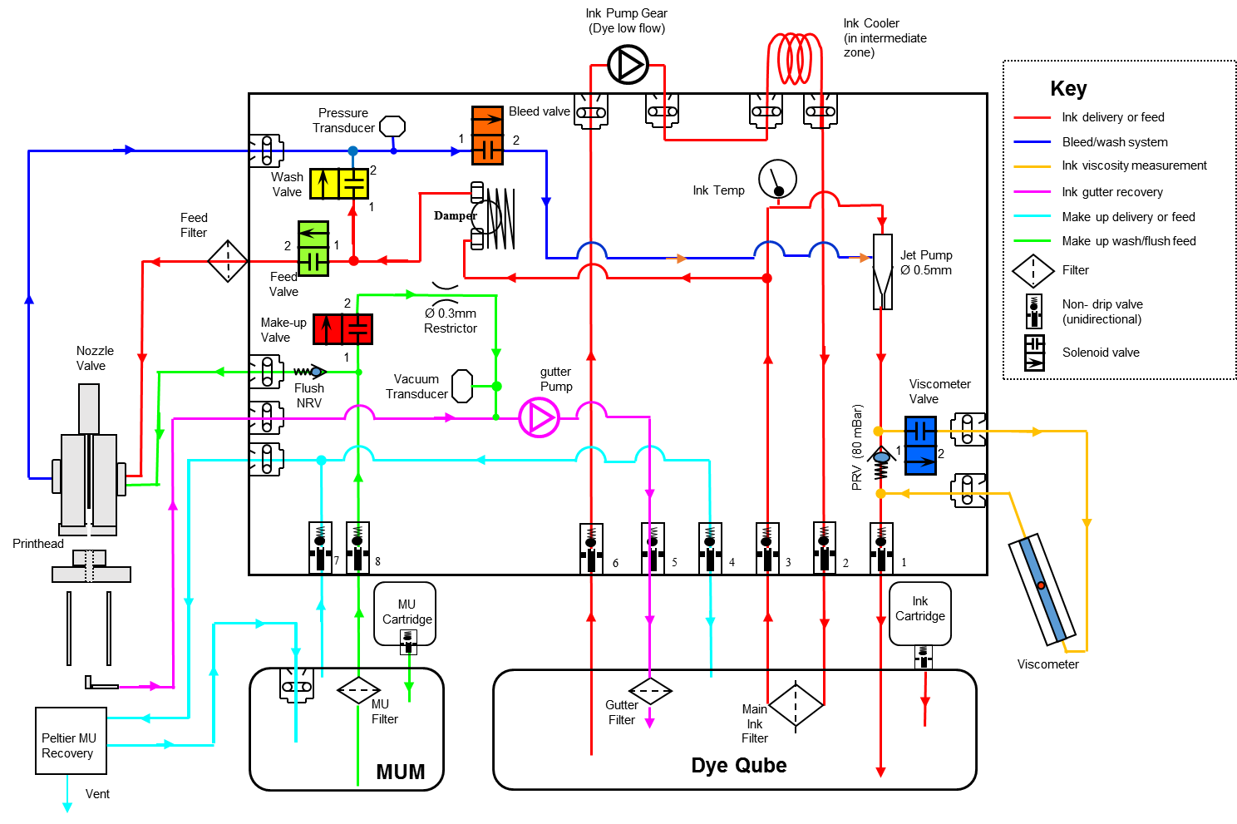

Figure . The ink management system of an Ax-series (Galileo/G2) printer, coloured lines represent fluid carrying tubing which have the same colour coding on the printer itself. Components are labelled in the figure or in the key. The main black square represents the printer body, the two modules are shown below but are also housed in the printer body, (MUM = make up module) and the filters of the modules are held in the lids.

The bleed/wash line (Figure 12 blue) removes ink or make up that has been flushed through the pinthead without being passed through the nozzle and returns it to the ink module, this system is mainly used for washing the printhead at shutdown or before start up to insure a clean head and nozzle. The gutter line (Figure 12 magenta) collects any non-printed ink and returns it to the ink module *via* a diaphragm pump and filter. The viscometer ink line (Figure 12 yellow) periodically delivers ink into the ball-fall-time viscometer to measure the viscosity of the ink. If viscosity is high, make up is delivered to the ink modules to dilute ink and reduce viscosity back to the target value.

The ball-fall-time viscometer works by filling a tube with ink, by filling the tube the ink pressure lifts a ball. Once the ball is at the top of the tube the ink flow is stopped and the time it takes for the ball to drop through the static ink under the force of gravity is proportional to the viscosity of the ink.

Lastly, there are two ink lines that manage make up fluid, one (Figure 12 cyan) delivers make up to the ink to dilute it thereby reducing ink viscosity, the other (Figure 12 green) carries make up fluid to the print head to flush out and clean the printhead when necessary. The ink and make up cartridges are used to top up fluids in the printer and allow the printer to be running whilst refiled, reducing down times.

## Printer function

### Drop phasing

Drop phasing is the method by which the CIJ printer synchronises the timing of its charging signal, this is done in order to charge the tip of the jet to produce drops with the charge requisite for printing. In a printer with drive frequency of 64 kHz, one drop is produced every 15.625 *μ*s, and full charging of this drop must occur before the drop breaks off. Furthermore, if the charging signal ends before break‑off then charge may be lost from the forming drop and this is why the charging system must be synchronised with the jet break-up.

When a voltage is applied to the charge electrode, a charge is induced on the earthed ink stream. Lower down in the charge electrode is a charge detection zone, the phase detector, that measures the charge on drops (Figure 13) thus allowing accurate phasing. In a 64 kHz Domino printer the print charging signal duration is 15.625 *μ*s,[4] the same as the duration to generate one drop. Phasing simply synchronises the start time of the charging, such that the end of the charging signal coincides as close as possible to drop break-off. Phasing signals are half that duration, at 7.8125 *μ*s.

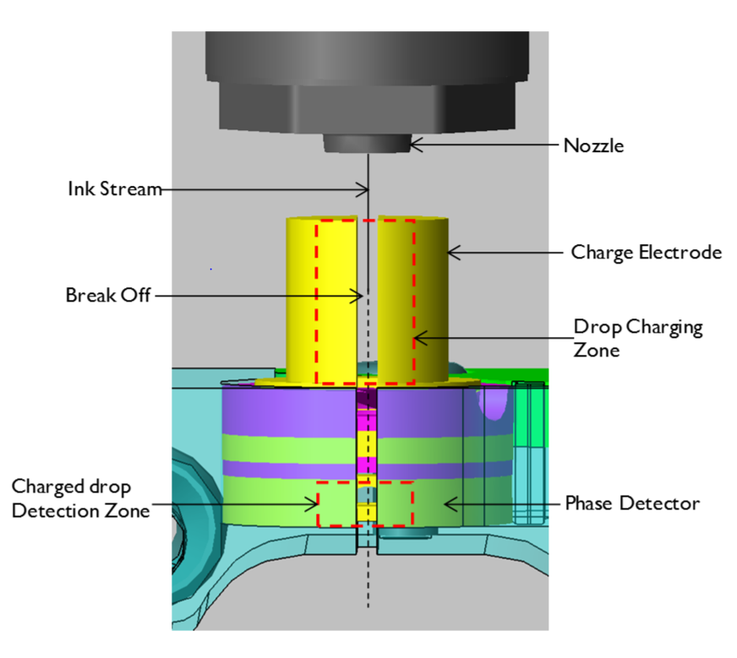

Figure . An illustrated schematic of the charge electrode in the Domino Ax-series printer.

When the printer is initialised, a full phase test is conducted by the printer in the charge electrode. The time period over which a drop is generated (1/frequency) is divided into 16 equal time periods, or phase periods (Figure 14). The test itself consists of measuring the charge on drops according to which time period the phase charging was initiated. If the tip of the jet is charged too early or late in the cycle the drop associated with that charging signal will carry little or no charge, thus falling short of a specified charge detection threshold, and that phase signal position will be failed. However, if the drop generated carries sufficient charge to exceed the threshold then that phase signal position will pass (Figure 15). The number of phase positions that pass is taken to be the detection window and it is expected that if drop charging occurs at a time period within the detection window the desired charge will be induced on the drop. Currently, the centre of the charging signal is set to meet the centre of the detection window in order to reliably achieve desired charging of droplets.

For phasing signals, typically -12 V (as opposed to ≥ +60 V for printed drops) is applied to the charge electrode over eight drop forming cycles, generating packets of eight drops that were all charged at the same phasing position. Using packets in place of single drops increases the accuracy of the charge measurement made in charge detection, due to the small charges involved. The small negative charge induced during phasing means the drops will still fall in the gutter and allows the undeflected stream to be aligned close to the gutter edge.

Phasing is also carried out periodically during the running of the printer as drift in ink and environmental properties can effect break-up and desynchronised charging. In newer printers only eight phase positions are explored to ensure the charging is still synchronised with break-off. This phasing can occur in between printing code and takes 2-4 *μ*s.

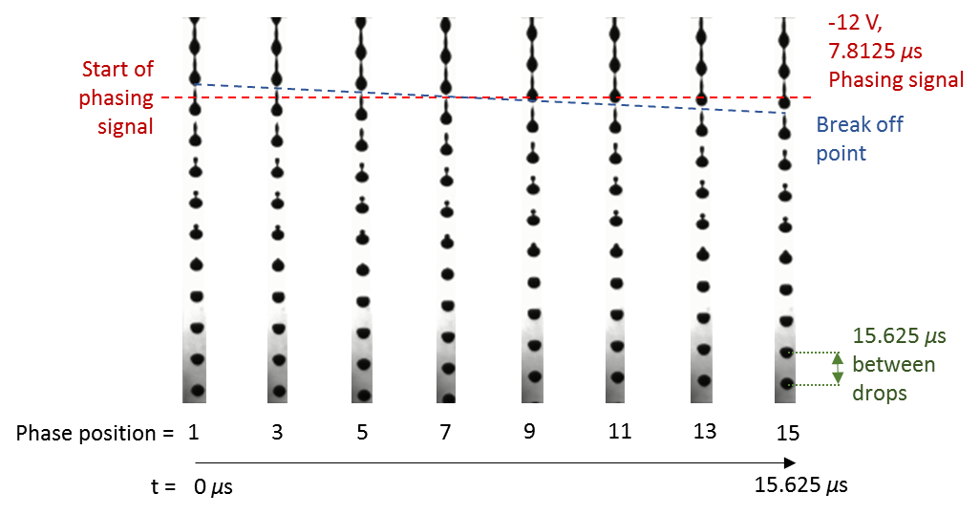

Figure . Phasing is used to synchronise charging with drop break-off in order to achieve the desired charge on drops to be printed. Drops break-off at the drive frequency which in this example is 64 kHz so a drop forming cycle is 15.625 *μ*s which is divided into 16 time periods, or phases. A phase signal attempts to induce charging for half a cycle, 7.8125 *μ*s. A charge detector then measures the charge on drops lower down the ink stream and if they carry sufficient charge to exceed a threshold they are deemed to pass; passing phases form the detection window. If tip charging is synchronised with the detection window drops will break-off with the desired charge for deflection.

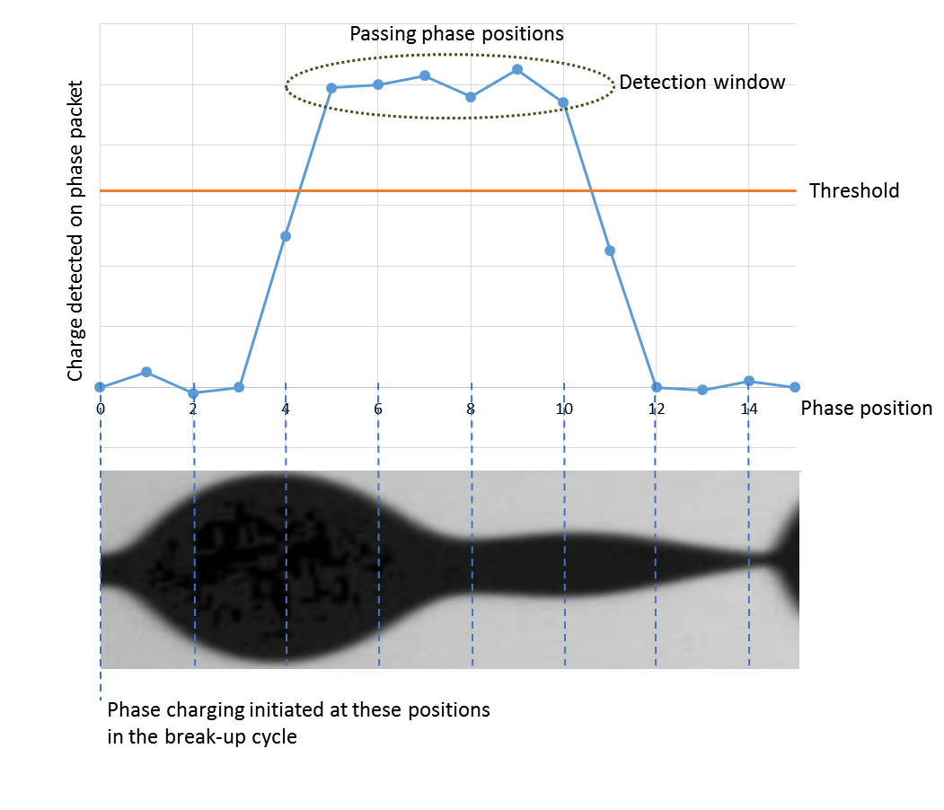

Figure . Plot of a typical phasing cycle (blue dots and line), with charge detected on the phase packet *versus* phase position (the position in the cycle at which half a cycle charging is initiated) plotted. A single break-up cycle of the jet is shown and illustrated with the phase positions marked (dashed blue lines).

### Raster and matrices

In continuous inkjet printers, printed drops are charged and deflected from the stream by an electric field produced by deflection plates. The amount of deflection is related to the magnitude of the charge applied to the droplet. In the simplest case there is a linear relationship between the charge applied to a drop and its impact position. However, in real conditions this is influenced by aerodynamic and electrostatic interactions between the drops. Therefore, voltage applied to a drop to achieve a given deflection is dependent upon the drops printed before and after, *i. e.* the deflection is pattern dependent.

When drops are printed, there are three different types of interactions that affect a drop’s trajectory, which are: electrostatic interactions, capacitive coupling, and aerodynamic interactions. Electrostatic interactions come from the fact that charges applied on individual droplets have the same polarity. During raster optimisation this phenomena manifests in undesired repulsion between the drops. This repulsion becomes greater between highly charged drops and with decreasing distance.

Capacitive coupling occurs within the charged electrode, where the presence of a charged drop affects the charging process of the next drop. The charge on the drop is the same polarity as the charge on the following drop and therefore repels any charge forming on the next drop. Therefore, the voltage applied on the charged drop to achieve a required deflection has to be increased when the preceding drop has been charged, where the increase is proportional to the charge on previous drop.

As a series of drops travel through the air, a drop can get effected by the slipstream of the preceding drop. Causing the drop to be stuck the slipstream, and thus changing the deflection for a given voltage. Aerodynamic interactions are very complex and slight changes in applied voltage can result in large changes in deflection.

The term “raster” represents a strategy for placing drops on the substrate. In its final form, the “raster” corresponds to a table of voltages determining the position of droplets for a given print format. The rasters form a core technology of continuous inkjet printers and directly dictate print quality, print format and speed that the printer can achieve.

Historically, raster development has been a highly skilled and time consuming task.[5] 40C – Project Lacey final report and user manual. However, a new project, Marley, has generated a new automation method, using a single flash imaging technique, which calculates the impact positions of drops in flight. The Marley rig can modify the charge values applied to printed drops, to achieve the optimum drop spacing for each stroke. Marley also enables new raster development techniques, such as drop stealing which enhances print speed and helps improve quality. The main components are the IDE, which is the user interface (written in C++) and the optimisation engine (written in MatLab).[6]

# The importance of dimensionless numbers

Dimensionless numbers are heavily utilised in engineering sciences, they are ratios whose values can be very informative about a system being considered and in comparing systems. They are numbers that are unitless, being the composite of dimensions that cancel to unity. Six dimensionless numbers that can be useful to calculate and consider bulk ink properties are introduced (Table 2) and described below.

|  |  |  |  |
| --- | --- | --- | --- |
| **Reynolds number** | $$Re=\frac{ρvL}{µ}$$ | $$\frac{inertial forces}{viscous forces}$$ | Low - viscous forces dominate inertia and capillary forces  High - inertia and capillary forces dominate viscous forces |
|  |  |  |  |
| **Weber number** | $$We=\frac{ρv^{2}L}{σ}$$ | $$\frac{inertial forces}{surface tension}$$ | Low - surface tension dominates inertia  High - inertia dominates surface tension |
|  |  |  |  |
| **Ohnesorge number** | $$Oh=\frac{\sqrt{We}}{Re}$$ | $$\frac{viscous forces}{\begin{aligned}inertia and \\ surface tension\end{aligned}}$$ | Low - inertia, surface tension and capillary forces dominate viscous forces  High - viscous forces dominate inertia, surface tension and capillary forces |
|  |  |  |  |
| **Capillary number** | $$Ca=\frac{μv}{σ}$$ | $$\frac{viscous forces}{surface tension}$$ | Low - capillary forces dominate viscous forces  High - viscous forces dominate capillary forces |
|  |  |  |  |
| **Deborah number** | $$De=\frac{t_{c}}{t_{p}}$$ | $$\frac{relaxation time}{observation}$$ | Low - slow system  High - fast system |
|  |  |  |  |
| **Weissenberg number** | $$Wi=\frac{μ\dot{γ}}{Eϵ}=\dot{γ}λ$$ | $$\frac{viscous forces}{elastic forces}$$ | Low - linear viscoelastic response  High - non-linear viscoelastic response |
|  |  |  |  |

Table . Introduces six dimensionless numbers that are informative when considering ink fluids and ink systems. Where *ρ* = density; *v* = velocity; *L* = characteristic length scale; *µ* = viscosity; *σ* = surface tension; *tc* = stress relaxation time; *tp* = time scale of observation; *γ* = shear rate; *E* = (bulk) modulus; *ε* = elongation rate; *λ* = relaxation time.

At first glance a series of ratios appear not provide a significant amount of insight into a system, however, they can be key to understanding the behaviour of a system. Consider the Reynolds number, providing a ratio between inertial forces and viscous forces allows for comparison of any system where an object is moving through a fluid. For example, a swimmer in water has a Reynolds number of 985000 (if ***ρ*** = 985 kg m-3; ***v*** = 1 m s-1; ***L*** = 1 m; ***µ*** = 1 x10-3 Pa s) but in honey the number may drop to 98.5 (if ***ρ*** = 985 kg m-3; ***v*** = 1 m s-1; ***L*** = 1 m; ***µ*** = 10 Pa s), in short a swimmer would glide a shorter distance in honey than water but pushing against honey would give them a greater forward thrust. Extending the example, a small particle moving through water would have a Reynolds number of 0.985 (if ***ρ*** = 985 kg m‑3; ***v*** = 1 m s-1; ***L*** = 1 x10‑6 m; ***µ*** = 1 x10-3 Pa s), indicating viscous forces dominate and instead of gliding and slowly being stopped by the resistive viscosity would decelerate rapidly. Typically, motion for micro or nano scale objects is viscosity dominated and not by momentum and inertia.

As the Reynolds number is useful for comparing movement through bulk fluids, the Weber and capillary numbers are useful in describing the interface dependant behaviour of fluids and drops. When surface tension or viscosity dominate of over inertia drops are less likely to splash as they hit a surface but lowered inertial forces would mean a great ease of disruption from air currents. Furthermore, the Ohnesorge provides a unified presentation of inertia, surface tension and viscosity and is commonly used to classify inks as well as predict whether they are suitable for the printer concerned. Unfortunately, the “optimal fluid parameters” (Reynolds, Weber and Ohnesorge numbers) that have been derived and published are for DoD ink systems,9 but are really more like [rules of thumb](http://www.stevenabbott.co.uk/Ohnesorge/index.html) and inks formulated to these fluid parameters have no guarantee of performing in the printer and make no predictions about end user properties.

If non-Newtonian or viscoelastic behaviour is exhibited by a system, additional dimensionless numbers should be considered. The Deborah number is used to define the timescale of a process, if we return to the pitch drop example, under normal timeframes we can expect pitch to be a solid and not flow, however, extending the observational time means that flow phenomena are observed (9 drops in ~100 years!). For inkjet printing, a typical ‘observation time’ would be microseconds or lower so a process that takes milliseconds would be considered slow, therefore the Deborah number becomes useful in removing the ambiguity of relative terms like ‘fast’ and ‘slow’, especially when relating processes like drop generation and polymer relaxation. The Weissenberg number balances viscous and elastic responses of a fluid, which in non-Newtonian fluids can change according to the shear rate, but is useful in considering if the resistance to shear of a system is dominated by viscosity or elasticity. For more information on how these numbers can be applied to inkjet printing read references,9,10 and how they have been applied at Domino, read “Viscosity Dependent Printhead Functions” (attached in Section 6.2.2).

# Chemistry of Inkjet inks

The physical properties of inks are defined by their chemical content, and the most successful inks are the simplest formulations that can achieve the desired physical properties and end user properties, whilst meeting restrictions placed on the ink by the printer design, regulatory and business concerns. In order to achieve this a formulation chemist has access to a range of chemicals that are described in good detail in the introductory text “Ink Chemistry Document”,11 for brevity they are summarised below (Table 3).

|  |  |  |
| --- | --- | --- |
| Domino term | Classification | Description |
| Solvent | Main solvent / Vehicle | Dissolves other components of the ink.  Defines the underlying physical properties of the ink.  Has a large effect on ink drying time, density, surface tension, viscosity, *et c.* |
| Co-solvent | Alters the general physical properties of the ink.  Can be used to increase solubility of certain components.  Provides dilution of main solvent for business and regulatory concerns. |
| Colourant | Dye | Soluble, coloured organic molecules or metal complexes.  Acts as a light absorber to provide colour to the printed ink.  Typically salts that increase the conductivity of the ink. |
| Pigment | Insoluble, coloured particles that have to be suspended as a colloid.  Acts as a visible light absorber to provide colour to the printed ink. |
| Binder | Resin (natural polymer) | Naturally derived, chemically altered polymer that typically has high molecular weights with large poly dispersity indices (PDI) and variable chemical functionalisation.  Increases adhesion and gloss or the printed drop.  Can alter hardness and flexibility of the printed drop.  Significantly alters solution viscosity. |
| Synthetic polymer | Fully synthetic polymers that typically have better controlled molecular weights, PDI and chemical functionalisation.  Increases adhesion and gloss or the printed drop.  Can alter hardness and flexibility of the printed drop.  Significantly alters solution viscosity.  Can reduce frictional coefficient of printed drop. |
| Additive | Conductivity salt | Soluble salts that increase the conductivity of the ink. |
| Surfactant (small molecule) | Reduces surface tension of the ink (at equilibrium, may have little effect on dynamic surface tension at break‑up).  Increases surface wetting.  Can help solubilise other components. |
| Surfactant (polymeric) / dispersants | Used to stabilise pigment particles into soluble colloid.  Reduces surface tension of the ink.  Increases surface wetting.  Can reduce frictional coefficient of printed drop. |
| Humectant | A hygroscopic substance that aids water retention. |
| Defoamer | A surfactant system that supresses foam formation in the ink. |
| Biocide | A preservative that prevents biological growth in the ink. |

Table . List of chemicals used in ink formulation with their generalised function of in the ink outlined.

Due to the heavy usage of polymers, colloids and surfactants in inks, knowledge of their behaviour is key to understanding the chemistry and physical properties of inks. The study of which is sometimes collected under the banner of ‘soft matter’ and its principles are introduced in the following sections. Often the discrepancies between predictions based on measured physical properties and true behaviour in inks are due to the microscopic behaviour of soft matter effecting the macroscopic system being considered.

## Surfactants

Surfactant is a broad term that describes any agent that accumulates at an interface and alters interfacial energy. The most commonly considered surface active agents are amphiphilic small molecules comprising a hydrophilic head and hydrophobic tail. In this case, a surfactant molecule consists of two distinct regions, one with a high density of dipolar, polarisable or charged groups which are favourably dissolved in water (or any similar medium); the other is a longer aliphatic region with little or no dipolar, polarisable or charged groups. Thus in any liquid, one region of a surfactant will be less soluble than the other and the result is the expulsion of the less soluble component to the interface. Surfactants at the interface have a lower chemical potential than the solvent at the interface, this is because the desolvation and orientation to the interacting medium of the low‑solubility region is energetically favourable.

Surfactants in solution act in equilibrium with surfactants at an interface. Whilst there is an energetic drive to accumulate and pack surfactants at an interface, this process requires partitioning and ordering of the surfactants decreasing the entropy of the system so a balance is met. Rigorous treatment of adsorption equilibria and behaviour is found elsewhere.12–14 In addition to expulsion to interfaces from solvent, surfactants can desolvate by means of forming micelles. A micelle is a structure in which the less soluble component of a surfactant is buried away from solvent amongst that same component of other surfactant molecules. The result can be a spherical or cylindrical structure containing a compartment of a different phase of liquid (Figure 16). Increased concentration of surfactant can then lead to other biphasic structures such as hexagonally packed cylinders and lamella. A consequence of this is that an additional equilibrium is set up of surfactants diffusing into and out of micelles, with associated energy barriers and kinetic effects meaning above a certain concentration of surfactant (the critical micellar concertation) no additional free surfactant is present in the system - the CMC can be viewed as a solubility limit.

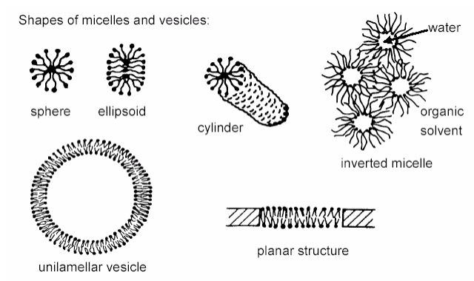

Figure . Schematic cross sections of structures formed by surfactants in solution. Surfactants are depicted with polar head groups (dots) and hydrophobic tails (lines).

Not all surfactants are created equal, there are various classes of small molecule and polymeric surfactant (Table 4) which all act to reduce interfacial energies and are suited to different applications. Surfactants can be grouped according to the identity of the polar head group into four classes: cationic, anionic, non-ionic and Zwitterionic (Table 4, line one); bear in mind that any charged surfactant will carry a counter-ion in solution to satisfy charge neutrality. Whilst this classification system has merit, it can be useful to think of surfactants more openly as modular systems with many options for each section including: type of polar head group, number of polar head groups, length of tails, degree of branching of tail *et c.* (Table 4). For inks, surfactants are chosen primarily to reduce surface tension, increase surface wetting, stabilise colloids and reduce the frictional coefficient of the printed dot.



Table . A survey of the possible surfactant structures with the simplest representation given (above) and possible modifications given in the table.

Surfactants can be further characterised by a dimensionless number - the critical packing parameter, CPP - that indicates the shape of the surfactant, and therefore suitable environments/applications. In order to use this parameter the volume occupied by the hydrophobic tail, ***V***, the area occupied by the polar head, ***A***, and the length of the tail, ***l***, are equated thus,

$CPP=\frac{V}{A l}$ (6)

a summary of the meaning of this result is given (Figure 17). However, care must be taken interpreting these results as the three input parameters can vary according to environment, an aliphatic chain will have a short effective length in a less favourable solvent or at raised temperature (polymeric) polar heads can expand significantly. The main use of this tool is to estimate if a surfactant will be suitable rather than the exact curvature of its ‘ideal’ interface.

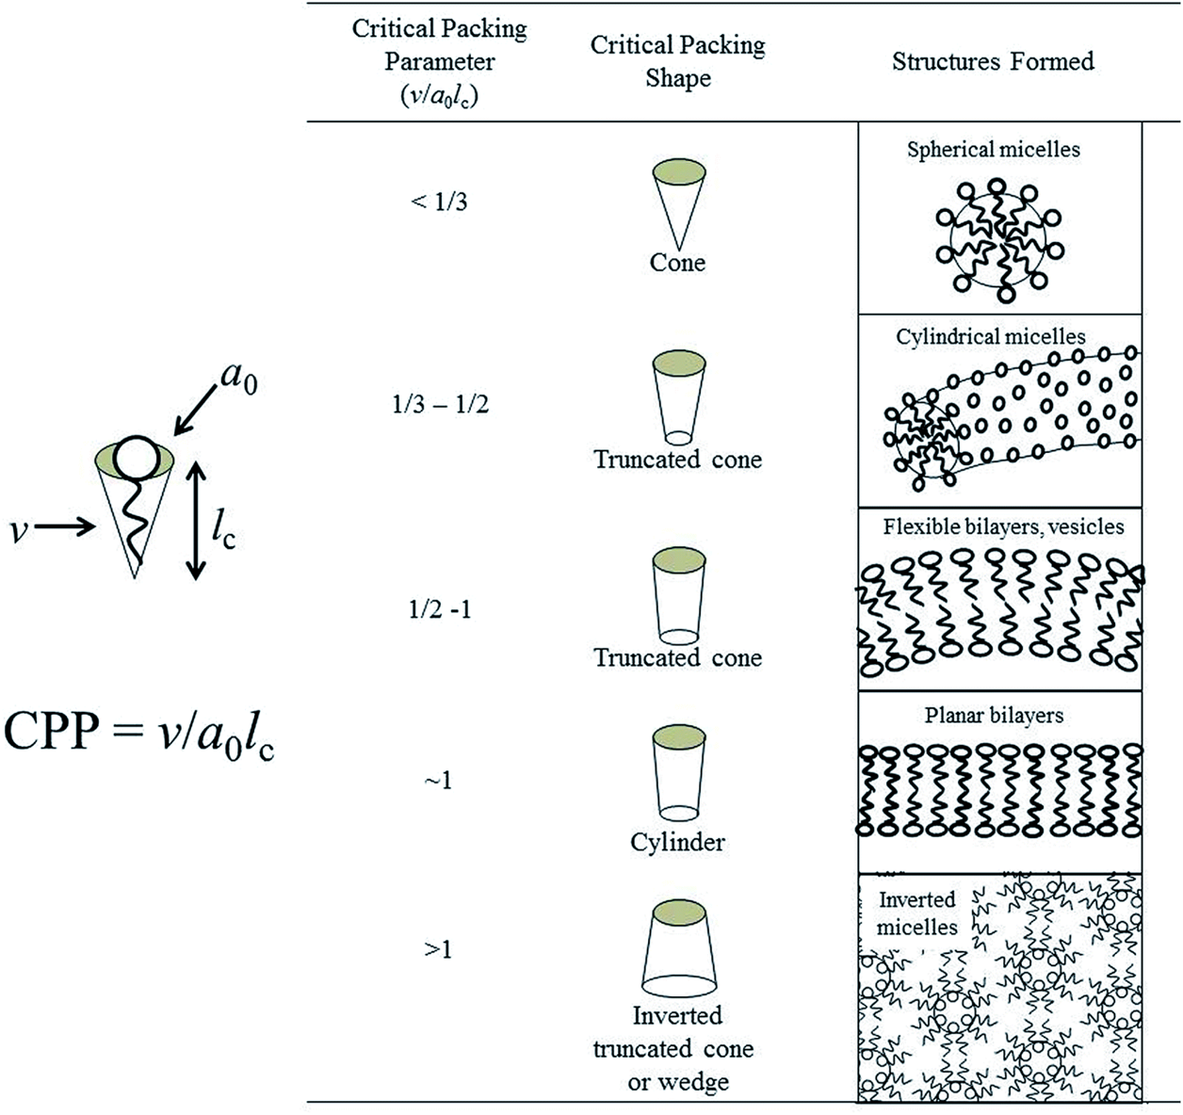

Figure . The favourability of surfactant structures are indicated by Israelachvili’s critical packing parameters. Image reproduced from reference.15

A couple of ink-centric surfactant examples are discussed here to apply what has just been discussed. The first is increased surface wetting, which is achieved by reducing the air/liquid surface tension, and in this case the interface has a low curvature. As a result roughly symmetrical surfactants (CCP ≈ 1) are chosen that provide very low surface tensions (σ ≈ 25 mN m-1). In place of hydrocarbon chains, siloxane or fluorocarbon chains are employed as hydrophobic tails as they tend to provide even lower surface tensions so effectively enhance surface wettability.

The second case is that of dispersants for pigment particles. In this case higher CPP values are desirable so that high curvature inverse micelles can be formed around the particle in organic solvent. Also desirable is a high affinity between the surfactant and the particle, as well as a low lability of the surfactant because the surfactant then will stay in place on the particle, keep it dispersed and not migrate to other regions in the system. Polymeric dispersants are typically employed because the cooperativity of multiple interactions with the surface create a high affinity, their high molecular weights reduce lability due to low diffusional coefficients and their long tails provide a high level of steric stabilisation to prevent the particles aggregating (section 5.3.3).

The kinetics of surfactant transport is a final consideration that must be made when considering inks. Dynamic surface tension was introduced earlier (section 2.1.5), and arises from the rate of diffusion of surfactants to an interface as well as the concentration of free surfactant. Surfactant constrained in micelles or on particles will be slower to diffuse to a nascent interface because of the additional energy barriers introduced by inclusion in these structures. Therefore, if a surfactant that is going to respond quickly to a nascent surface and lower its surface tension is required a high rate of diffusion and a high CMC are desirable. For instance, a small surfactant with a reasonable amphiphilic character and a CPP of around 1 (would have a high diffusion rate and be less likely to form micelles) would be preferable to a large polymeric surfactant with a high CPP (that would diffuse slowly and have a high propensity to form stable micelles).

## Polymers in solution

Polymers are essential for Domino’s inks, providing a means to adhere to non-porous substrates, disperse pigments, increase resistance and achieve desirable viscosities. However, polymers are also the most troublesome component in dye-based ink formulations due to their complex solution behaviour, which arises from their size. Polymers are large molecules, exhibiting some unique properties both in solution and in the solid phase. In dilute solution, polymers take a shape that is dependant on the solvent, the covalent linkages along the chain and the non-covalent inter‑chain interactions.

Taking a single polymer chain as an example, stretching to its full extent will create a long chain, at full length the polymer has the fewest conformational degrees of freedom possible - it is limited to one conformational state. Entropically, this is significantly disfavoured as the chain is very well ordered so conformation entropy drives the chain to coil up to a state with the greatest number of degrees of freedom. Then polymer coil can be considered as a soft sphere with a radius of gyration, ***RG***.

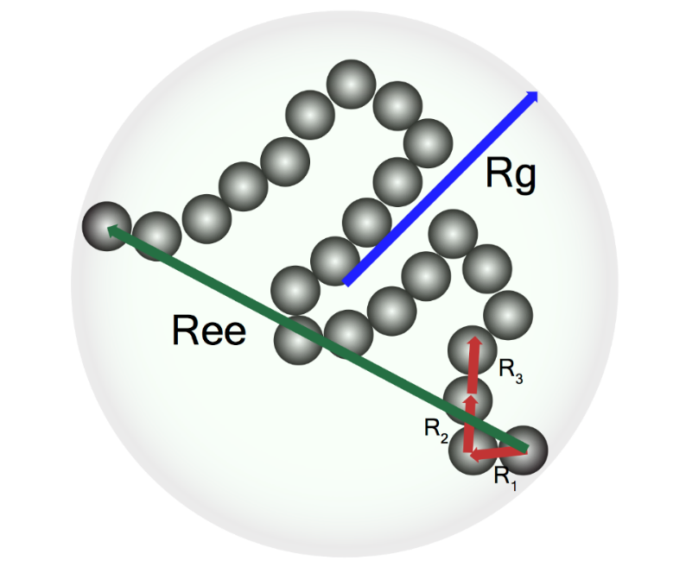

Figure . Segments of a polymer chain (grey spheres) have an inter segment radius (Rn), which generate an end-to-end polymer length (Ree) and a radius of gyration (RG) that are dependent on the angle between segments.

In the state of maximum extent there will also be the fewest interactions between parts of the polymer as they are held furthest apart, on the other hand it will be exposed maximally to the surrounding solvent. Therefore the chemical potential of mixing (in this case the change in free energy upon dissolving a polymer) also effects conformation. If the chemical potential of mixing is zero then the solvent/solvent, polymer/solvent and polymer/polymer interactions are of equal energy, as a result the polymer takes the size as dictated by the conformation entropy. This state is called the theta state, the solvent a theta solvent, and the temperature this happens at the theta point.

Away from the theta state the radius of gyration is effected by the chemical potential of mixing, if solvent/polymer interactions are favoured then the system will maximise those interactions and increase ***RG***. If solvent/polymer interactions are less favoured then the polymer will shrink in solution to reduce these less favourable solvent/polymer interactions.

The rigidity of chain segments and their linkages also effects solution size, structure and behaviour by effecting how the chain can coil and how many degrees of freedom each state has. Rigid monomers, bulky side groups and aromatic linkages will act increase a polymer’s rigidity and give it a rod-like structure in solution. Changing the aspect ratio of a polymer effects diffusion and flow properties, and the reduction in flexibility leads to a reduction in solubility. Furthermore, the more rigid the polymer chain is the less able it is to entangle other chains, thus effecting bulk properties in solution as well as in the solid state.

The inherently large size of polymers means that they are kinetically hindered in most situations, notably polymer diffusion can be very slow relative to small molecules. The combination of slow kinetics and resisting conformational stretching results in polymers significantly increasing the viscosity of a solution. An intrinsic viscosity can be determined for polymers which indicates its contribution to viscosity by extrapolating to the y‑axis intercept from a plot of concentration versus viscosity.

Plots of viscosity versus concentration are linear for a hard sphere model, however, polymers can interact with one another. When one polymer coil entangles with another considerable conformation charge is required to pull the polymers past one another, this is slow and energetically unfavourable. This means at concentrations at or above a point where polymer coils are significantly overlapping with each other in solution viscosity response to concentration becomes non-linear with an increasing slope. This concentration is called the critical coil overlap concentration, ***c\****, and can be defined microscopically as the concentration at which polymers in solution start interacting or macroscopically as the concentration at which viscosity/concentration curves become non-linear.

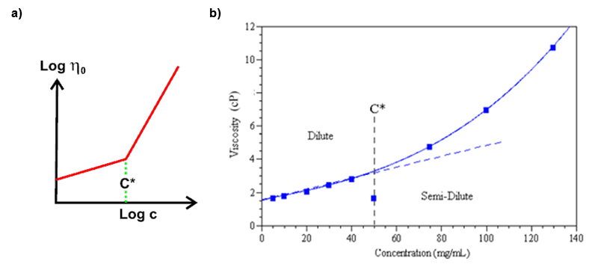

Figure . Plots that illustrate the critical coil concentration, c*, as the point between the dilute and semi-dilute polymer regimes.16

Below the critical coil overlap concentration, the solution is termed dilute and behaves like a small molecule solution. Above c*, the solution is termed semi-dilute and intercoil interactions become significant to the bulk properties - most CIJ inks are formulated to be at the low concentration end of the semi-dilute region. In this regime viscoelastic responses are possible due to entanglement of polymer coils. Further concentration leads to concentrated solutions at the critical entanglement concentration, ***c‡***, then become swollen solids. Increasing concentration increases the expected elastic response of the system whilst also increasing viscosity, for example, in a drying ink drop.

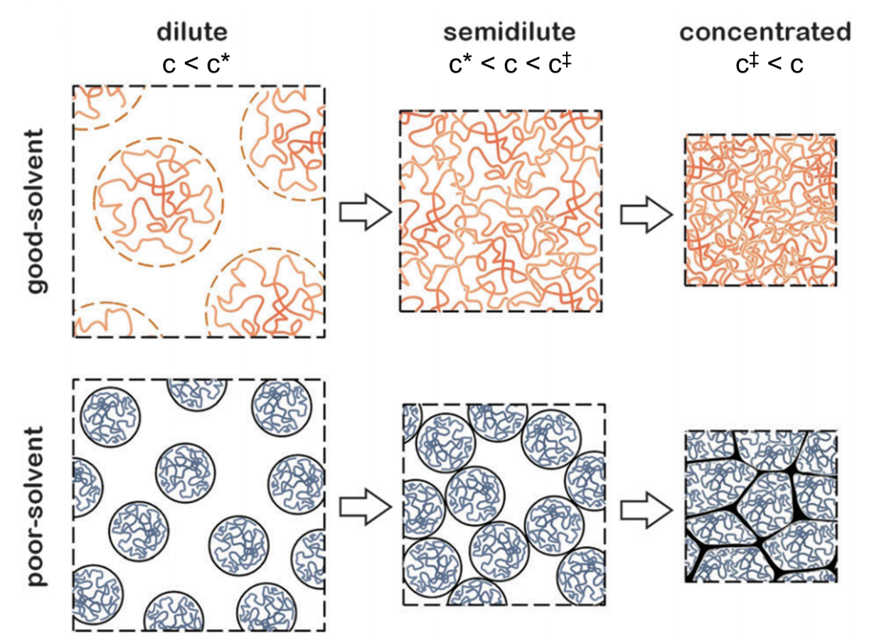

Figure . Illustrated here, there are three of concentration regimes in which polymer solutions exhibit significantly different bulk behaviour. Reproduced from reference.17

## Colloids

Here a colloidal system is defined as one where: one or more discontinuous phases are dispersed within a continuous phase, where the transport of the discontinuities is dominated by Brownian motion. Loosely speaking, a system where small particles of gas, liquid or solid is dispersed within a continuous (bulk) medium of gas, liquid or solid in any combination except gas in gas as all gases are miscible. The above definition differs subtly from the IUPAC definition,

“State of subdivision such that the molecules or polymolecular particles dispersed in a medium have at least one dimension between approximately 1 nm and 1 μm, or that in a system discontinuities are found at distances of that order.”18

with two significant outcomes in terms of what is included, firstly using Brownian motion as a differentiation, in place of a specified length, scale allows the inclusion of ‘fine suspensions’ of larger particles, therefore includes pigmented inks. Secondly, polymer solutions are not included unless they demonstrate phase separation by generating micelles or solvent excluding particles, in other words, it differentiates between homo and heterogeneous systems.

Colloids are ubiquitous and will be encountered in everyday life. They are typically classified by which medium is dispersed in which phase (Table 5) but these are idealised and can be loose, for example if water micelles were to suspended by surfactants in a pigmented ink the system is both a sol and an emulsion. Sols are of particular interest to ink science due to the use of pigmented inks.

|  |  |  |  |  |
| --- | --- | --- | --- | --- |
|  | | Dispersed phase | | |
| Gas | Liquid | Solid |
| Dispersing phase | Gas | none - all gases are miscible | **Liquid aerosol** | **Solid aerosol** |
| fog, hairspray, deodorant sprays | icy fog, clouds, smoke |
| Liquid | **Foam** | **Emulsion** | **Sol** |
| whipped cream, shaving foam, baking bread | milk, mayonnaise, lotions | pigmented ink, blood, engine oil, paints |
| Solid | **Solid foam** | **Gel** | **Solid sol** |
| styrofoam, marshmallow, pumice | gelatine, jelly, butter | gold-ruby glass, pearl, opal |

Table . Classification of colloid systems, the classification is given in bold, examples are given under the class.

### Colloid instability

Very few colloids are thermodynamically stable, this is an important point. By the definition used above, microemulsions are the only thermodynamically stable colloids. Forming a stable colloid typically requires the use of kinetic trapping that prevents the attainment of the thermodynamic minima by generating large thermodynamic barriers to aggregation of the discontinuous phase. For the same reasons, generating a colloid requires an energetic input either by high shear[7] or nucleation of the discontinuous phase.

### DLVO theory - attractions, repulsions and Zeta potentials

van der Waal forces[8] provide an ever present attractive potential between particles, and generate the thermodynamic drive for the aggregation of dispersed particles and is a relatively strong force. However, this attractive force decays with a 1/r6 relationship, where r is the interparticle distance, thus is only effective over short distances and drops of quickly with increasing interparticle spacing.

The surface charge carried by dispersed particles provides a repulsive force between particles (assuming that they carry like charges, this holds if they have the same composition) which follows Coulomb’s law. The force induced by the repulsion of like charges decays with a 1/r2 relationship, thus is effective over greater distances than the attractive force. Unfortunately, at r = 0 the Coulombic interparticle forces tend to be significantly weaker than the attractive van der Walls forces.

DLVO theory equates the total potential of interaction between two particles by summing these repulsive and attractive forces and plots it against interparticle separation (Figure 21). This gives a very clear picture of how particles are likely to interact: If the potential is a steady drop to lower energy, particles will attract over all distances and aggregation will be fast; if a significant energy barrier (≈ 20 kBT) exists then it is likely that particles will be repulsed before the attractive forces can drive aggregation; and if there is a small energy well at a separation greater than the energy barrier occurs flocculation (weak aggregation that can be reversed by low shear forces/stirring) will be likely.

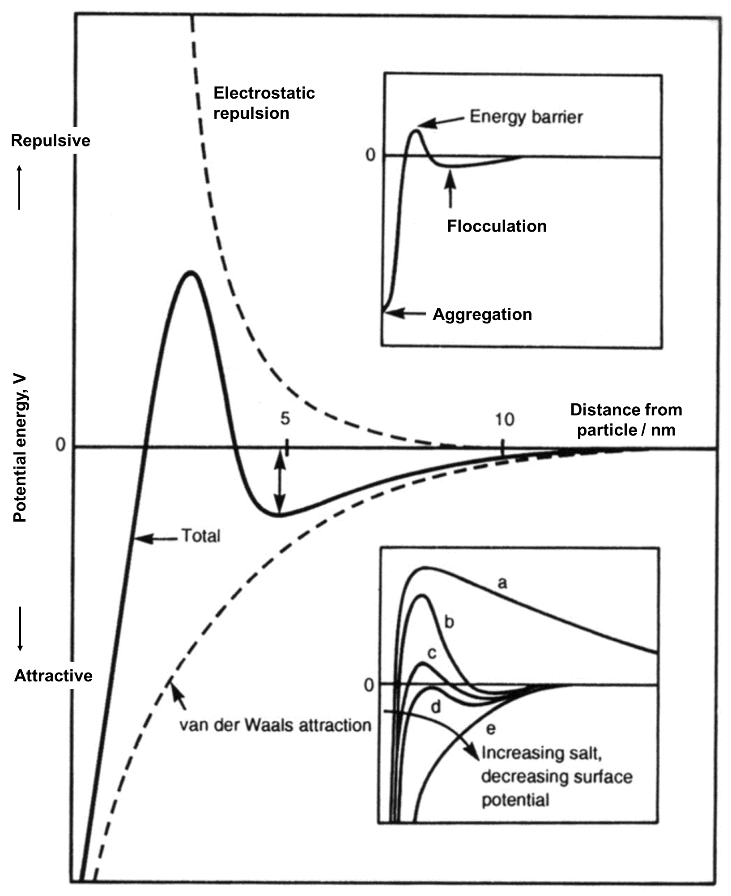

Figure . An example plot of potential energy *versus* distance according to DLVO theory for a stable colloid. The potential energy is the sum of the attractive London/van der Waals forces and the electrostatic repulsion and has a potential barrier between flocculation (shallow minimum) and irreversible aggregation (deep minimum) (top right insert). A reduction in the repulsive forces leads to less stable colloids (bottom right insert). Figure reproduced from reference.19

The Debye length, ***Κ-1***, provides an indication of the magnitude of charge screening in a system by describing the distance over which electric potential will decrease by 1/e and is equated with,

$Κ^{-1}=\sqrt{\frac{ε_{0}ε_{r}k_{B}T}{2N_{A}e^{2}I}}$ (7)

where, ***ε0*** is the permittivity of vacuum, ***εr*** is the permittivity of the medium, ***kB*** is Boltzmann constant, ***T*** is temperature, ***NA*** is the Avogadro number, ***e*** is the elementary charge of the electrolyte and ***I*** is the ionic strength of the solution. Long Debye lengths are preferable for stabilising colloids as the repulsive force extends over a greater distances.[9]

From equation 7, increasing the permittivity of the medium or the temperature will increase the Debye length. For example, water (***εr*** = 88) will increase the Debye length more than MEK (***εr*** = 19) will and this longer range electrostatic repulsion in water, generally, leads to a more stable colloid. The extension of the Debye length according to permittivity can be thought of in terms of the alignment of dipoles in the media. This is because the electric field generated by the charge on a particles surface will cause dipoles in the solvent to align, and with each alignment the field is extended, with a shallower gradient.

Increasing the ionic strength, salt concentration or charge density of the ions in the medium dispersing the colloid leads to a reduction in the Debye length, and a reduction in the colloidal stability. The presence of ions in solution act to screen the electrostatic repulsion between particles, this is because the charge on a particle attracts opposite charge to its surface. Using an example, coating a negative particle in cations, driven by Coulombic attraction, acts to reduce the effective charge of the particle. Extending this, the high concentration of the cationic layer and the negative charge of the particle causes a concentration ions in a diffuse layer around the particle. This effect is termed the Helmholtz double layer effect.

The layer of opposite charge that forms around a particle is termed the Stern Layer, the higher concentration than bulk of ions is termed the Gouy-Chapmen diffuse layer. This double layer effect screens charge and reduces the effective electrostatic repulsion of dispersed particles. As the particle moves through the medium, it will carry the layers with it, increasing the effective size of the particle by the addition of soft double layer. The border between the double layer and the bulk solution is termed the slip plane, and the potential of the electric field at the slip plane is termed the Zeta potential (figure x).

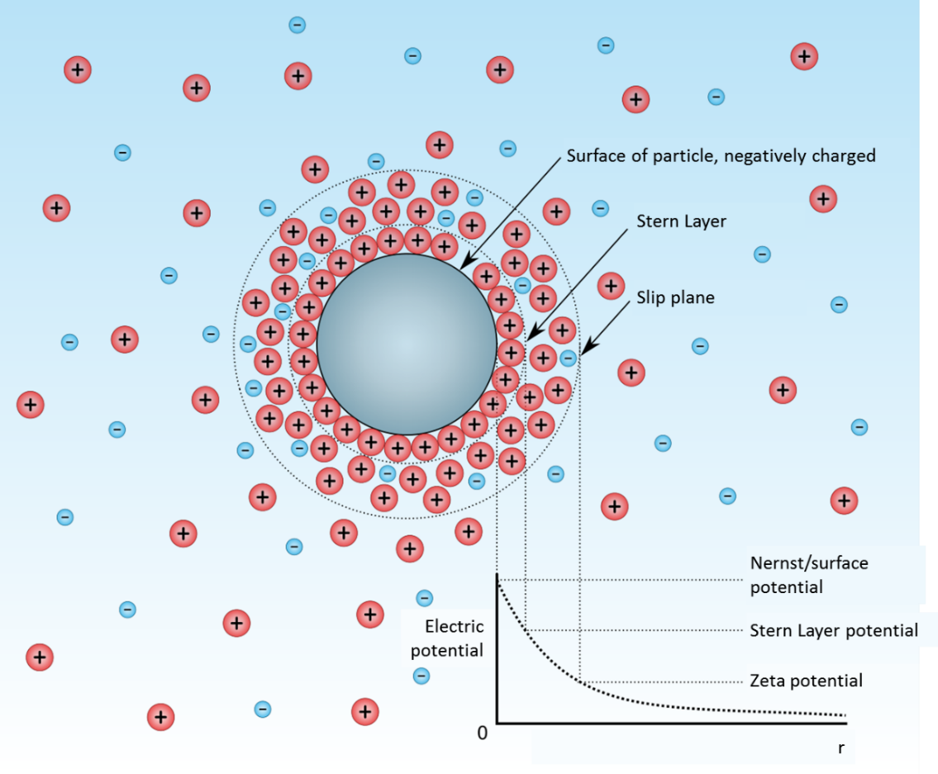

Figure . Illustration of a particle is solution (grey) surrounded by a Stern Layer, Gouy-Chapman diffuse ion layer and bulk solution. The slip plane describes a sphere around the particle that travels with the particle as it moves, at the slip plane the strength of the electric field is termed the Zeta potential. The electric potential is plotted according to distance, r, from the particle (bottom left). Figure reproduced from reference.20

### Steric stabilisation

Surfactants can be employed to increase the stability of colloids through a steric stabilisation effect. If surfactants adsorb to a particle surface they will present a radial array of chains into the surrounding medium, much like a micelle. This arrangement can then provide a repulsive potential as bringing two particles together will force the chains to start overlapping, and any overlapping or interdigitation of the chains leads to drop in the entropy of the system due to the reduction in degrees of freedom in the chains and a reduction (Figure 23). In addition, there is a reduction in the energy of mixing as solvent becomes excluded between the two particles, inducing an osmotic pressure that pushes approaching particles apart.

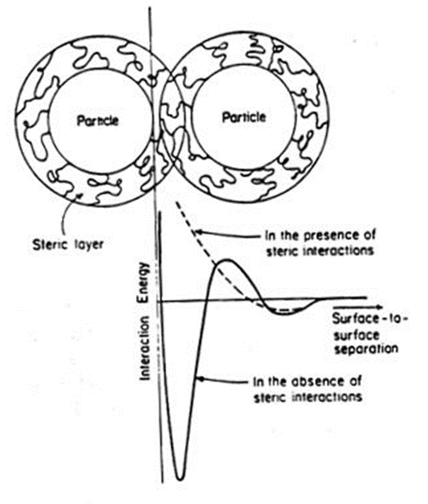

Figure . Generation of a steric layer around colloidal particles stabilises the system by increasing repulsive forces. This repulsion is induced by the entropically unfavourable compression of surfactant chains between the approaching particles

The repulsive potential generated by the entropic effect is dependent on:

* Temperature.
* Absorbed mass of surfactant.
* Length/radius of gyration of the surfactant chains adsorbed on the surface (more simply the surfactant layer thickness). This I why polymeric surfactants are commonly used as dispersants.
* The compatibility of the chain with solvent (Flory-Huggins parameter, ***Χ***).

Higher temperatures lead to greater entropic contributions to energy and therefore increased the effect of steric stabilisation (however, increasing the temperature of the system will also energise particles and allow them to exceeded greater energy barriers so could lead to colloid instability). The more surfactant is adsorbed to the particle, the more chains there will be to provide the entropic barrier. Longer chains have more degrees of freedom and extend further into solution so both increase the length and potential of repulsion. Finally, the compatibility of the chains with the solvent effects their radius of gyration and the energy lost from desolvation.

### Depletion and bridging flocculation

Polymers and polymeric surfactants in solution with a colloid can also cause instabilities. If the separation between particles is less than the radius of gyration of any dissolved polymers then these polymers will not diffuse into the interparticle gap. This produces an area of low (/zero) concentration in solution, and this concentration gradient will produce an osmotic pressure from this zone to the bulk solution. The result is that of a pseudo-attraction between the particles as solvent attempts to drain away from the low concentration area between particles. This phenomenon is known as depletion flocculation. Thus, high concentrations of non-adsorbed, high molecular weight polymers can destabilise colloids

Bridging flocculation occurs when a polymer chain becomes adsorbed to two different particles and acts as a bridge. The chain then acts as a spring to bring the two particles together reducing colloidal stability. This will occur with random co-polymer or triblock co-polymer surfactants and/or in situations of low surfactant coverage of particles with surfactant.

### Stokes separation

Settling, separation, creaming and sedimentation are all terms that describe the phenomenon of Stokes separation. The force of gravity drives the separation of colloids according to buoyancy of the dispersed medium in the dispersing medium. For example, emulsified fats in milk rise to the surface and can be creamed and dust settles out of air. The velocity of separation is given by,

$v=\frac{2.18\left(ρ_{p}{-ρ}_{l}\right)gr^{2}}{μ}$ (8)

where ***ρp*** is the density of the dispersed phase, ***ρl*** is the density of the dispersing medium, ***g*** is the acceleration due to gravity, ***r*** is the radius of the dispersed bodies and ***µ*** is the viscosity of the dispersing medium. It follows that the time for this process is,

$t=\frac{h}{v}$ (9)

where h is the height to travel and combing gives,

$t=\frac{hμ}{2.18\left(ρ_{p}-ρ_{l}\right)gr^{2}}$ (10)

Stokes separation can lead to reversible flocculation or to irreversible aggregation depending on the stability of the system. The former case is easily remedied by stirring or shaking, so inducing flow through an ink module or cartridge will homogenise a separating pigmented ink.

### Repercussions for pigmented inks

Block copolymer dispersants are used to sterically stabilise colloidal pigments in CIJ inks, the dispersions are generated by milling large particulates in the presence of the dispersant to allow the kinetically slow polymers to coat the nascent pigment particle surfaces. This high surface coverage with low lability, large polymers acts to provide an entropic barrier to particle aggregation which is the thermodynamically most favoured state. This is in addition to the stabilisation inferred by the inherent charge on the particles that generates Coulombic repulsion in opposition to the attraction due to London forces.

The addition of conductivity salts to colloidal dispersions will act to destabilise the pigmented inks due to charge screening and the reduction in the Debye length. Dissolved large polymers will induce depletion flocculation that can also reduce the stability of the ink. Furthermore, differential densities of dispersed and dispersing phases leads to significant Stokes separation in our relatively low viscosity pigmented inks, this can be remedied by stirring if the colloid is sufficiently stable against aggregation.

For example, titanium dioxide (rutile phase), a white pigment, has a high density (4.23 g cm-3) and high Hamaker constant (43 x10-20 J) meaning the colloidal particles will sediment rapidly and be highly attracted to one another. Therefore, titania containing inks must be frequently stirred or flowed, have low salt levels and high dispersant coverage with large dispersants to be stable enough to use in a printer.

One last consideration that must be made is that of the size and shape poly dispersity indices of colloids, this is because polydisperse systems can have higher packing efficiencies (small particles fill the gaps that large particles leave between one another) which leads to a lower stability of colloid. Furthermore, hardened pumps are required to handle pigmented ink systems due to their abrasive nature and the hardened gear pumps act to mill particles to smaller sizes and change the PDi, thus additional dispersant is required in solution to coat nascent particle surfaces.

It is this multitude of variables, printer modification and the inherent instability of colloids that means that they are only used in CIJ inks where necessary, typically for applications that require white colour or high opacity.

# Case studies

## Development of a black dye based ink for glass marking - Frink - Andrew Kyriacou

Domino’s current glass marking inks are I-234BK for marking wet bottles and I‑207BK for marking dry bottles. Both are removable by a caustic wash process so that the bottles can be re-used. There have been some reports of unreliable printer performance with both inks, particularly I-234BK.[10] There are also reports of difficulty in removing I-234BK with the caustic wash process as very specific wash conditions are required.[11] In addition I-234BK has presented some issues in manufacturing, sometimes giving viscosities far from the specification.[12] The aim of this project is to develop a black ink which can cover the applications of both I-234BK and I-207BK with reliable printer performance, good adhesion to dry and wet bottles as well as being easy to remove with a caustic wash process.

### I-579TF

I-579TF was the formulation that was proposed at the gate 3 review.[13] It had excellent adhesion on wet glass when printing on the body of bottles sourced from the UK but we were later sent older bottles from India and were informed that they printed on the necks. I-579TF had very poor adhesion to the necks of these bottles. The print drops would spread very badly on contact with condensation giving illegible codes. Print messages on dry glass had very poor resistance to water immersion leading to the drops falling off the bottles.

|  |  |  |
| --- | --- | --- |
| Material | % | Function |
| MEK | 60 | Main solvent |
| Ethanol | 3 | Alcohol solvent which improves the solubility of water in MEK |
| Water | 3 | Increases the amount of conductivity imparted by the dye and hydrolyses silane |
| Joncryl 682 | 25.5 | High acid number acrylic giving alkali washability |
| Dynasylan 1146 | 1 | Aminosilane oligomer which couples the ink to glass substrates |
| Valifast 3808 | 7.5 | Solvent black 29 dye giving conductivity. Also improves the solubility of the silane / acrylic combination in MEK |

Table . I-579TF formulation details.

|  |  |
| --- | --- |
| Test | Number of rubs required to remove |
| Rub resistance on wet glass immediately after printing | 1 |
| Rub resistance 10 mins after printing on wet glass | 2-3 |
| Rub resistance 1 hour after printing on wet glass | 2-3 |
| Rub resistance 24 hours after printing on wet glass | 3-5 |
| Water Immersion resistance after printing on dry glass (1 hour) | Drops fall off |
| Water Immersion resistance after printing on wet glass (1 hour) | 1 |
| Caustic wash removal | Removed immediately with wash additives |

Table . I-579TF end user properties.

|  |  |
| --- | --- |
| Advantages | Issues |
| Stable ink  Reliable printer running  Easy caustic washability | Poor print quality on wet glass  Poor adhesion on wet and dry glass |

Table . I-579TF advantages and issues.

The change in bottles and print placement on the bottles has highlighted as a major weakness in the adhesion of I-579TF. In order to improve on this the polymer resin in I‑234BK, Carboset 514A was re-visited in I-616TF.

### I-616TF

This formulation replaces the DMMSP-PEI from I-234BK with the Dynasylan 1146 (lower molecular weight than DMMSP-PEI) from I‑579TF. The adhesion is improved over I-579TF but not as good as I-234BK.

|  |  |  |
| --- | --- | --- |
| Material | % | Function |
| MEK | 78 | Main solvent |
| Carboset 514A | 15 | High acid number acrylic giving alkali washability |
| Dynasylan 1146 | 1 | Aminosilane oligomer which couples the ink to glass substrates |
| Valifast 3820 | 6 | Solvent black 27 dye giving conductivity |

Table . I-616TF formulation details.

|  |  |
| --- | --- |
| Test | Number of rubs required to remove |
| Rub resistance on wet glass immediately after printing | 2-3 |
| Rub resistance 10 mins after printing on wet glass | 7-10 |
| Rub resistance 1 hour after printing on wet glass | >10 |
| Rub resistance 24 hours after printing on wet glass | >10 |
| Water Immersion resistance after printing on dry glass (1 hour) | 2-3 |
| Water Immersion resistance after printing on wet glass (1 hour) | >10 |
| Caustic wash removal | Removed in less than 1 minute. |

Table . 616TF end user properties.

|  |  |
| --- | --- |
| Advantages | Issues |
| Improved adhesion over 579TF  Caustic washable with additives | Wet glass adhesion not as good as 234BK  Viscous Carboset 514A resin difficult to handle |

Table : I-616TF advantages and issues.

These results indicate that the glass adhesion promoting properties of Dynasylan 1146 are not as strong as DMMSP-PEI. The next step was to move to an adhesion promoter with reactivity in between these two materials, Dynasylan TRIAMO which is a triamino functional trimethoxysilane.

### I-618TF

As well as the silane adhesion promoter being changed to Dynasylan, isobutyl isobutyrate has been added as a hydrophobic tailing solvent and water added to pre‑hydrolyse the silane. The glass adhesion is much improved over I-616TF.

|  |  |  |
| --- | --- | --- |
| Material | % | Function |
| MEK | 70 | Main solvent |
| Isobutyl isobutyrate | 6 | Hydrophobic tailing solvent improving water resistance |
| Water | 0.5 | Hydrolyses silane |
| Carboset 514A | 16 | High acid number acrylic giving alkali washability |
| Dynasylan TRIAMO | 0.5 | Triamino functional trimethoxysilane which couples the ink to glass substrates |
| Valifast 3820 | 7 | Solvent black 27 dye giving conductivity |

Table . I-618TF formulation details.

|  |  |
| --- | --- |
| Test | Number of rubs required to remove |
| Rub resistance on wet glass immediately after printing | 7-10 |
| Rub resistance 10 mins after printing on wet glass | >10 |
| Rub resistance 1 hour after printing on wet glass | >10 |
| Rub resistance 24 hours after printing on wet glass | >10 |
| Water Immersion resistance after printing on dry glass (1 hour) | 5-7 |
| Water Immersion resistance after printing on wet glass (1 hour) | >10 |
| Caustic wash removal | Removed in less than 1 minute. |

Table . I-618TF end user properties.

|  |  |
| --- | --- |
| Advantages | Issues |
| Wet glass adhesion comparable to 234BK  Better dry glass adhesion than 234BK  Caustic washable with additives | Build up on print head during continuous running at all test temperatures with A series plus 75 and 60 µm nozzles  Viscous Carboset 514A resin difficult to handle |

Table . I-618TF advantages and issues.

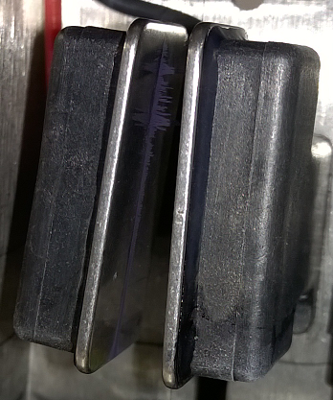

Figure . Deflector plates after running I-618TF for 24 hours.

In terms of end user properties this formulation is superior to I-234BK in that the wet glass adhesion is comparable while the dry glass adhesion is better. However, the in-printer performance is unacceptable with a significant amount of material seen to build up on the deflector plates. For this reason I-618TF could not be recommended for scale up and system test.

The next step was to take the information learned about using a hydrophobic tailing solvent as well as the use of Dynasylan TRIAMO, and apply this to the Joncryl 682 based formulations.

### I-621TF

The 3 different coloured dyes are present to facilitate ease of caustic wash. It was found during a separate piece of work that certain dyes were washed from the substrate significantly more easily than others and these 3 were selected from the results.[14] The tetrabutylammonium acetate salt allows the silane to be easily dissolved in the polymer solution, a function which was previously achieved by the solvent black 29 dye. Pentyl acetate was selected as opposed to isobutyl isobutyrate due both of these solvents appearing to work well in this system but pentyl acetate is already an existing part.

|  |  |  |
| --- | --- | --- |
| Material | % | Function |
| MEK | 56.75 | Main solvent |
| Pentyl acetate | 5 | Hydrophobic tailing solvent increasing water resistance |
| Water | 3 | Increases the amount of conductivity imparted by the salt and hydrolyses silane |
| Joncryl 682 | 27 | High acid number acrylic giving alkali washability |
| Dynasylan TRIAMO | 0.25 | Triamino functional trimethyoxysilane |
| TBA(PF6) | 1.75 | Conductivity salt giving the majority of conductivity |
| TBA(OAc) | 0.25 | Improves solubility of acrylic / silane combination |
| Valifast Red 3304 | 2 | Solvent red 8 dye |
| Oil Blue 613 | 2 | Solvent blue 5 dye |
| Valifast Yellow 3170 | 2 | Solvent yellow 151 dye |

Table I-621TF formulation details.

|  |  |
| --- | --- |
| Test | Number of rubs required to remove |
| Rub resistance on wet glass immediately after printing | 2-3 |
| Rub resistance 10 mins after printing on wet glass | 5-7 |
| Rub resistance 1 hour after printing on wet glass | >10 |
| Rub resistance 24 hours after printing on wet glass | >10 |
| Water Immersion resistance after printing on dry glass (1 hour) | 5-7 |
| Water Immersion resistance after printing on wet glass (1 hour) | 5-7 |
| Caustic wash removal | Removed immediately |

Table . I-621TF end user properties.

|  |  |
| --- | --- |
| Advantages | Issues |
| Improved print quality over 579TF  Caustic washable without additives | Adhesion on wet bottles still poor  Acetate salt very expensive  Blue and yellow dyes not suitable for food packaging |

Table . I-621TF advantages and issues.

The print quality is vastly improved over I-579TF with the codes printed on wet bottle necks now being legible despite a small amount of spreading. However the rub resistance of these printed codes is still relatively poor compared to I-234BK and I‑618TF.

### I-623TF

In I-623TF the Dynasylan TRIAMO has been replaced by DMMSP-PEI for its stronger glass adhesion properties. All other aspects of the formulation have remained the same.

|  |  |  |
| --- | --- | --- |
| Material | % | Function |
| MEK | 56 | Main solvent |
| Pentyl acetate | 5 | Hydrophobic tailing solvent increasing water resistance |
| Water | 3 | Increases the amount of conductivity imparted by the salt and hydrolyses silane |
| Joncryl 682 | 27.5 | High acid number acrylic giving alkali washability |
| DMMSP-PEI | 0.5 | Dimethoxymethylsilane functional polyethyleneimine |
| TBA(PF6) | 1.75 | Conductivity salt giving the majority of conductivity |
| TBA(OAc) | 0.25 | Improves solubility of acrylic / silane combination |
| Valifast Red 3304 | 2 | Solvent red 8 dye |
| Oil Blue 613 | 2 | Solvent blue 5 dye |
| Valifast Yellow 3170 | 2 | Solvent yellow 151 dye |

Table . I-623TF formulation details.

|  |  |
| --- | --- |
| Test | Number of rubs required to remove |
| Rub resistance on wet glass immediately after printing | 3-5 |
| Rub resistance 10 mins after printing on wet glass | 5-7 |
| Rub resistance 1 hour after printing on wet glass | >10 |
| Rub resistance 24 hours after printing on wet glass | >10 |
| Water Immersion resistance after printing on dry glass (1 hour) | >10 |
| Water Immersion resistance after printing on wet glass (1 hour) | 5-7 |
| Caustic wash removal | Removed immediately |

Table . I-623TF end user properties.

|  |  |
| --- | --- |
| Advantages | Issues |
| Improved adhesion over 621TF  Caustic washable without additives | Adhesion on bottles still poor  Acetate salt very expensive  Blue and yellow dyes not suitable for food packaging |

Table . I-623TF advantages and issues.

The adhesion is marginally improved over I-621TF but is still not at the level of I‑234BK or I-618TF. It was suspected that even though only present in a very small amount, the high hygroscopicity of tetrabutylammonium acetate may be the culprit.

### I-632TF

I-632TF is essentially I-623TF without tetrabutylammonium acetate. The DMMSP-PEI still dissolves in this system but takes significantly longer and requires vigorous agitation.

|  |  |  |
| --- | --- | --- |
| Material | % | Function |
| MEK | 56 | Main solvent |
| Pentyl acetate | 5 | Hydrophobic tailing solvent increasing water resistance |
| Water | 3 | Increases the amount of conductivity imparted by the salt and hydrolyses silane |
| Joncryl 682 | 27.5 | High acid number acrylic giving alkali washability |
| DMMSP-PEI | 0.5 | Dimethoxymethylsilane functional polyethyleneimine |
| TBA(PF6) | 2 | Conductivity salt |
| Valifast Red 3304 | 2 | Solvent red 8 dye |
| Oil Blue 613 | 2 | Solvent blue 5 dye |
| Valifast Yellow 3170 | 2 | Solvent yellow 151 dye |

Table : I-632TF formulation details.

|  |  |
| --- | --- |
| Test | Number of rubs required to remove |
| Rub resistance on wet glass immediately after printing | 3-10 |
| Rub resistance 10 mins after printing on wet glass | 5-10 |
| Rub resistance 1 hour after printing on wet glass | >10 |
| Rub resistance 24 hours after printing on wet glass | >10 |
| Water Immersion resistance after printing on dry glass (1 hour) | >10 |
| Water Immersion resistance after printing on wet glass (1 hour) | 5-10 |
| Caustic wash removal | Removed immediately |

Table : I-632TF end user properties.

|  |  |
| --- | --- |
| Advantages | Issues |
| Reduced cost compared to 623TF  Caustic washable without additives | Adhesion on bottles very variable  Blue and yellow dyes not suitable for food packaging |

Table : I-632TF advantages and issues.

The adhesion of I-632TF is very variable and sometimes very good, but on other occasions similar to I-623TF. This borderline behaviour may be due to slight environment changes between the tests. When it was found out the formulations require food packaging approval (to print on PET bottles) this formulation was no longer suitable so was not pursued further.

# I-631TF

Since the formulation needs food packaging approval, a screening was carried out on each of our conductivity salts which are on the Swiss Ordnance list.

It should be noted that order of addition is important with this formulation. The pentyl acetate should not be added until after the DMMSP-PEI has been added and mixed for 90 minutes. If this holding period is not employed, a precipitate forms upon addition of the pentyl acetate.

## Choice of salt and dye

In order to select the most suitable salt and dye from an end user properties perspective, a screening test was carried out testing the effect of different materials on glass adhesion as well as caustic washability.

|  |  |
| --- | --- |
| Material | Level |
| MEK | 57 % |
| Pentyl acetate | 5 % |
| Water | 3 % |
| Joncryl 682 | 27.5 % |
| DMMSP-PEI | 0.5 % |
| *Salt* | 1 % |
| HBDL N36B | 6 % |

Table : General formulation for the screening of different salts.

|  |  |  |  |  |
| --- | --- | --- | --- | --- |
| Screening of different salts | | | | |
| Bottle | Rub resistance immediately after printing on wet glass | Rub resistance after 1 hour water immersion, printed on wet glass | Rub resistance after 1 hour water immersion, printed on dry glass | Caustic washability |
| TBA(PF6) | 2-3 | 5-7 | 5-7 | Code completely removed |
| TBA(Br) | Precipitate which blocks filter | | | |
| TEA(Br) | Precipitate which blocks filter | | | |
| LiNO3 | Precipitate which blocks filter | | | |
| KSCN | 2-3 | 5-7 | >10 | Code completely removed |

Table : The effect of different salts on end user properties on glass bottles.

The bromide and nitrate containing salts each produced a precipitate and led to filter blockages. TBA(PF)6 gave reduced water resistance when printed on dry glass, making KSCN the preferred salt. It should be noted that TBA(PF)6 did not cause this issue with the previous formulations which suggests this is due to an interaction with the charged solvent black 29 dye.

The same screening test was then carried out for different dyes.

|  |  |
| --- | --- |
| Material | Level |
| MEK | 57 % |
| Pentyl acetate | 5 % |
| Water | 3 % |
| Joncryl 682 | 27.5 % |
| DMMSP-PEI | 0.5 % |
| KSCN | 1 % |
| *Dye* | 6 % |

Table : General formulation for the screening of different dyes.

|  |  |  |  |  |
| --- | --- | --- | --- | --- |
| Screening of different dyes | | | | |
| Bottle | Rub resistance immediately after printing on wet glass | Rub resistance after 1 hour water immersion, printed on wet glass | Rub resistance after 1 hour water immersion, printed on dry glass | Caustic washability at  74 OC |
| HBDL N36B | 2-3 | 5-7 | >10 | Code completely removed |
| Valifast 3808 | 1 | 1 | 2-3 | Code completely removed |
| Valifast 3820 | 2-3 | 5-7 | >10 | Slight ghost code left |
| Valifast 3830 | 2-3 | 5-7 | >10 | Code completely removed |
| Oil Black 860 | 2-3 | 5-7 | >10 | Slight ghost code left |

Table : The effect of different dyes on the end user properties on glass bottles.

Valifast 3808 by far gave the worst performance with very poor rub resistance in all tests. It also exhibited the same spreading seen in I-579TF giving illegible codes. Vailfast 3820 and Oil Black 860 gave slight ghost coding during caustic wash so the two preferred dyes are Valifast 3830 and HBDL N36B. Valifast 3830 was selected due to less staining of the filter paper when the formulation was diluted and filtered, although neither of them caused a blockage. This led to the I-631TF formulation.

|  |  |  |
| --- | --- | --- |
| I-631TF | | |
| Material | **%** | **Function** |
| MEK | 57 | Main solvent |
| Pentyl acetate | 5 | Hydrophobic tailing solvent increasing water resistance |
| Water | 3 | Increases the amount of conductivity imparted by the salt and hydrolyses silane |
| Joncryl 682 | 27.5 | High acid number acrylic giving alkali washability |
| DMMSP-PEI | 0.5 | dimethoxymethylsilane functional polyethyleneimine |
| KSCN | 1 | Conductivity salt |
| Valifast 3830 | 2 | Solvent black 27 dye |

Table : I-631TF formulation details.

|  |  |
| --- | --- |
| Test | Number of rubs required to remove |
| Rub resistance on wet glass immediately after printing | 2-3 |
| Rub resistance 10 mins after printing on wet glass | 3-5 |
| Rub resistance 1 hour after printing on wet glass | >10 |
| Rub resistance 24 hours after printing on wet glass | >10 |
| Water Immersion resistance after printing on dry glass (1 hour) | >10 |
| Water Immersion resistance after printing on wet glass (1 hour) | 5-7 |
| Caustic wash removal | Removed immediately |

Table 30: I-631TF end user properties.

|  |  |
| --- | --- |
| Advantages | Issues |
| Suitable for use on food packaging  Acceptable performance on glass bottles | Poor initial adhesion on wet glass  Precipitate forms over time  Precipitate has impact on jet stability |

Table : I-631TF advantages and issues.

While the formulation is now suitable for use on food packaging, the initial rub resistance after printing on wet glass is initially poor but this does improve over the course of 1 hour. Communication with the marketing team indicated that this would likely be acceptable so I‑631TF was progressed to printer testing. The formulation ran very well in i-Tech printers with 75 µm, 60 µm and 60 µm XS nozzles for 48 hours in each of the chambers. However the ink failed on the final jet stability test, with a build-up of solid material being observed in the nozzles.

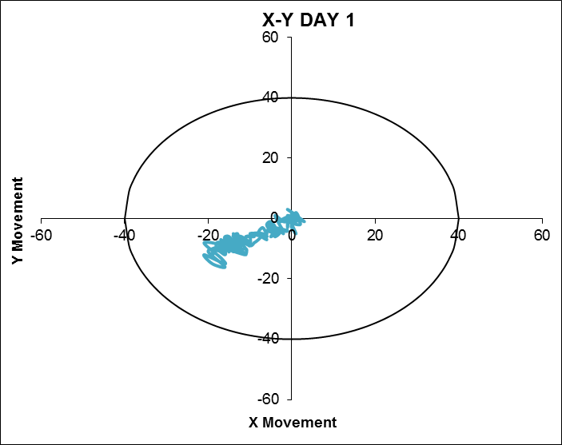 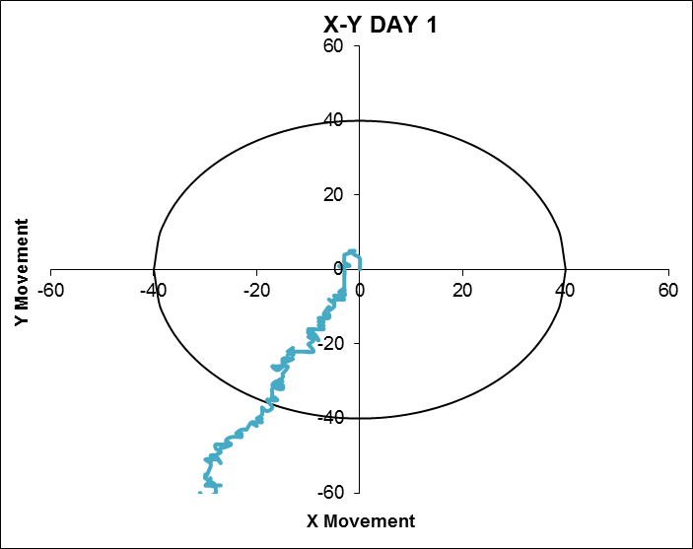

Figure 26: Jet stability tests for I-631TF with a 60 µm nozzle. Left: start. Right: End.

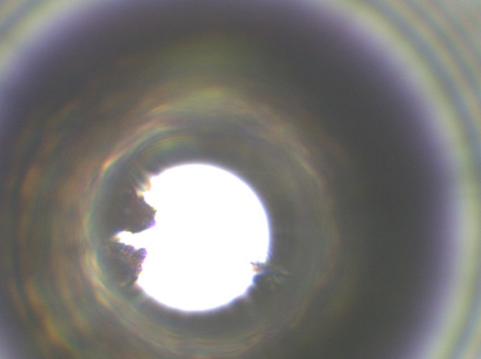 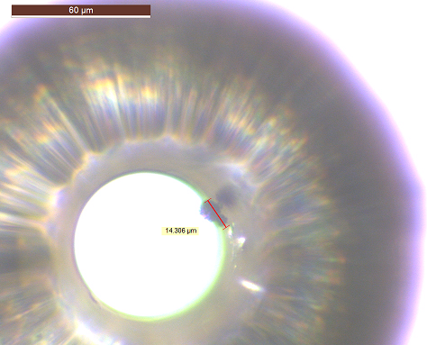

Figure : 60 µm nozzle under microscope after failed jet stability test. Left: Immediately after JSR test. Right: After ultrasonic cleaning and repetition of JSR test.

## Precipitate formation in I-631TF

An investigation into the causes of this solid build up was carried out. Apart from a small degree of staining, no filtration issues were seen in the static ageing samples so ink sample were retrieved from the printers to see if the shear effects of the printers were playing a role. Once again, nothing was seen on the filter papers apart from a small amount of staining which wouldn’t normally be considered worrisome. Bottles containing ink samples retrieved from the printers which failed jet stability testing were inverted (Figure 2) and specs of solid material were observed on the sides of the bottles. This is in contrast to a bottle of the same batch of ink that was not run in a printer, which did not show this solid material so the ageing was being accelerated by shear from the printer. It is interesting that this material was not detected by filtration but it is likely that the glass adhesion properties of the ink were causing this precipitate to stick to the glass of the bottles so could not be observed when filtering.

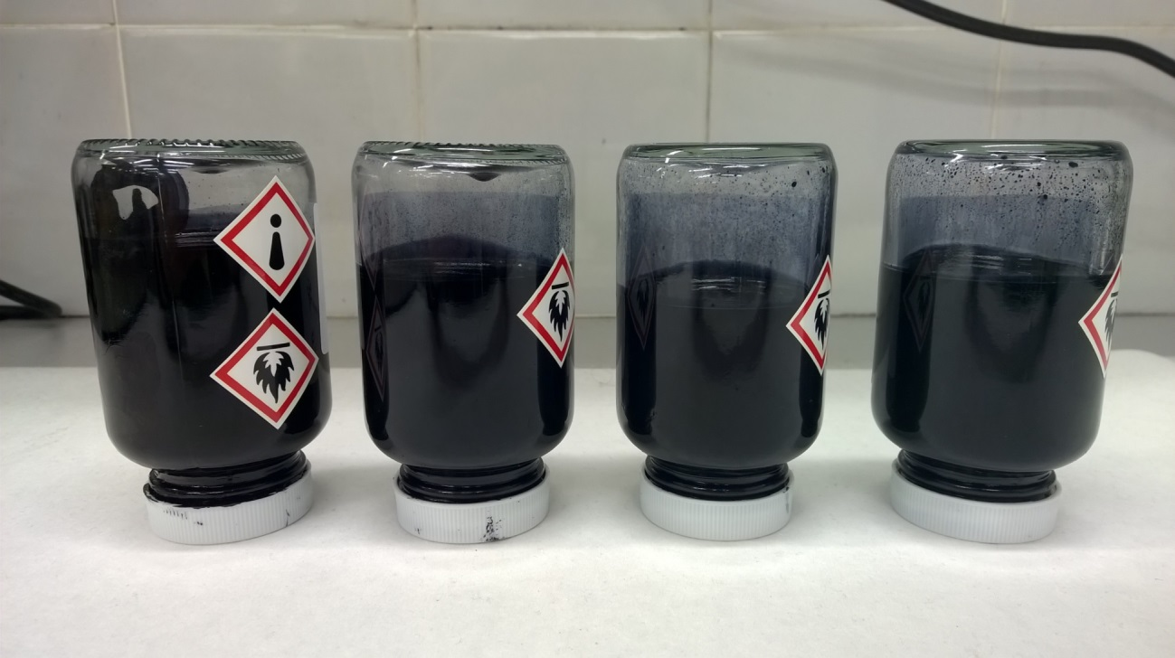

Figure : I-631TF samples from same printer batch. Starting from left to right – not been in printer, 75 µm, 60 µm, 60 µm XS.

The bottles from the static ageing test were inverted and they showed a similar solid material clinging to the sides of the bottles, getting progressively more severe as the storage temperature increased.

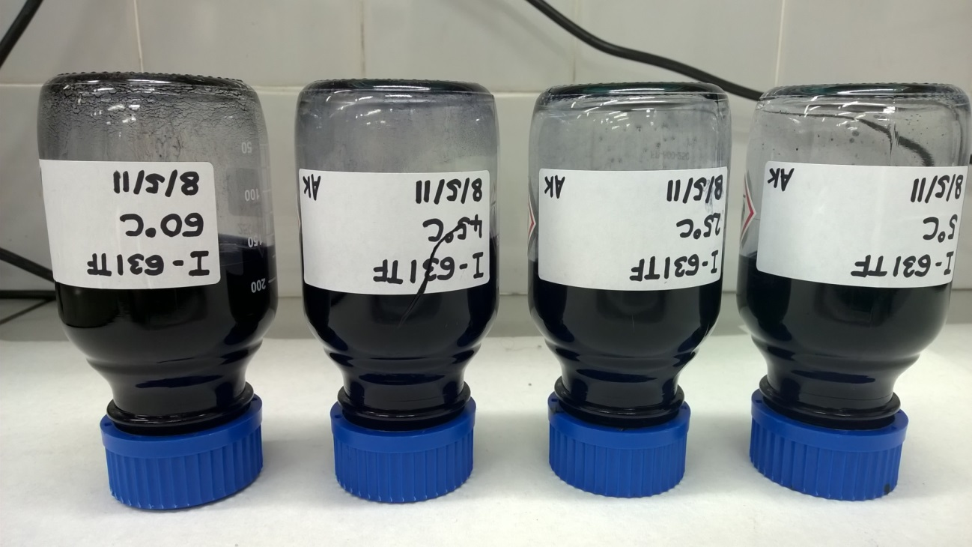

Figure : I-631TF 12 week static ageing samples. Starting from left to right – 60 OC, 45 OC, 25 OC, 5 OC.

Two samples of I-631TF were made, but without KSCN so that there was no salt present in the formulation, and stored at 60 OC and 45 OC. After 4 weeks the bottles were inverted and no solid material was observed. Given that other inks contain the combination of KSCN and solvent black 29, this suggests that the precipitate is formed by an interaction between KSCN and the silane.

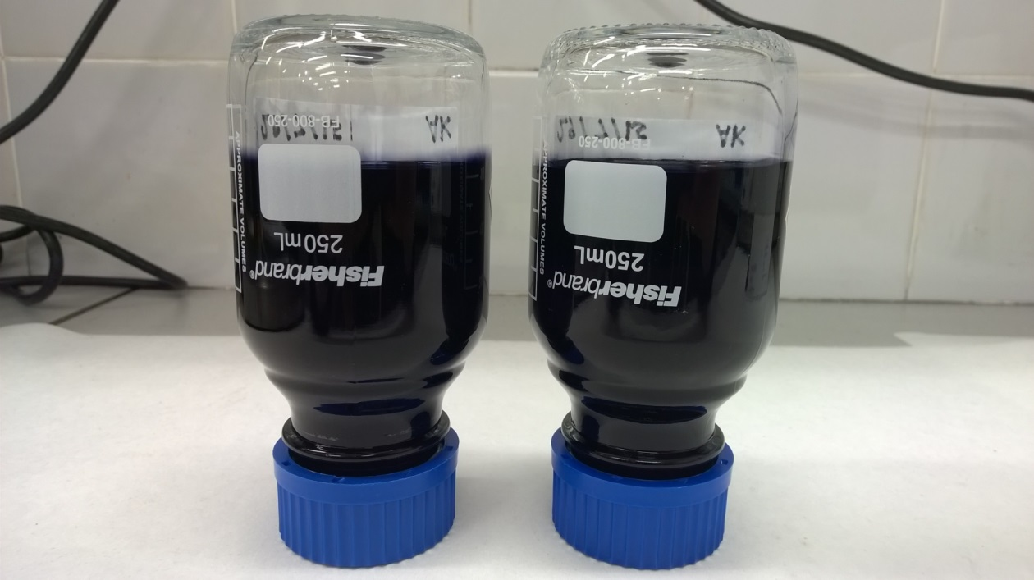

Figure : I-631TF aged for 4 weeks without salt. Left – 60 OC, right – 45 OC.

# I-635TF

I-635TF is similar to I-631TF except with no conductivity salt and with HBDL N36B instead of Valifast 3830. The level of dye had to increase to 10 % to achieve a printable conductivity and at this level Valifast 3830 is too expensive at ~ £80/kg. HBDL N36B by comparison is ~ £29/kg.

|  |  |  |
| --- | --- | --- |
| I-635TF | | |
| Material | **%** | **Function** |
| MEK | 54 | Main solvent |
| Pentyl acetate | 6 | Hydrophobic tailing solvent increasing water resistance |
| Water | 4 | Increases the amount of conductivity imparted by the dye and hydrolyses silane |
| Joncryl 682 | 25.5 | High acid number acrylic giving alkali washability |
| DMMSP-PEI | 0.5 | dimethoxymethylsilane functional polyethyleneimine |
| HBDL N36B | 10 | Solvent black 29 dye |

Table : I-635TF formulation details.

|  |  |
| --- | --- |
| Test | Number of rubs required to remove |
| Rub resistance on wet glass immediately after printing | >10 |
| Rub resistance 10 mins after printing on wet glass | >10 |
| Rub resistance 1 hour after printing on wet glass | >10 |
| Rub resistance 24 hours after printing on wet glass | >10 |
| Water Immersion resistance after printing on dry glass (1 hour) | >10 |
| Water Immersion resistance after printing on wet glass (1 hour) | >10 |
| Caustic wash removal | Removed immediately |

Table 33: I-635TF end user properties.

|  |  |
| --- | --- |
| Advantages | Issues |
| Improved adhesion over 631TF  Does not form precipitate over time | PEI difficult to dissolve in system  PEI missing from several regulatory inventories  PEI from an non–preferred supplier  Low conductivity |

Table : I-635TF advantages and issues.

The adhesion of I-635TF is vastly improved over I-631TF and does not form a precipitate over time. This formulation would give the required properties but there were concerns from the regulatory group since DMMSP-PEI is missing from several inventories which would limit which territories we could sell the ink into. In addition the operations group have concerns over the suppler of this material, Gelest, and would prefer not to use them. As such this formulation was not progressed further.

# I-645TF

This formulation swaps the DMMSP-PEI with Dynasylan 1146 which is from a preferred supplier, Safic Alcan / Evonik, and had good ageing stability in the I-579TF formulation.5 Isobutyl isobutyrate was reintroduced at this point due to the variability seen in rub resistance when printing on wet glass. Isobutyl isobutyrate is more hydrophobic than pentyl acetate so would give the formulation the best chance of penetrating the condensation layer on the glass and having acceptable rub resistance.

|  |  |  |
| --- | --- | --- |
| I-645TF | | |
| Material | **%** | **Function** |
| MEK | 55.5 | Main solvent |
| Isobutyl isobutyrate | 6 | Hydrophobic tailing solvent increasing water resistance |
| Water | 4 | Increases the amount of conductivity imparted by the dye and hydrolyses silane |
| Joncryl 682 | 25 | High acid number acrylic giving alkali washability |
| Dynasylan 1146 | 1 | Aminosilane oligomer which couples the ink to glass substrates |
| HBDL N36B | 9.5 | Solvent black 29 dye |

Table : I-645TF formulation details

|  |  |
| --- | --- |
| Test | Number of rubs required to remove |
| Rub resistance on wet glass immediately after printing | 3 – 5 |
| Rub resistance 10 mins after printing on wet glass | 7 – 10 |
| Rub resistance 1 hour after printing on wet glass | >10 |
| Rub resistance 24 hours after printing on wet glass | >10 |
| Water Immersion resistance after printing on dry glass (1 hour) | >10 |
| Water Immersion resistance after printing on wet glass (1 hour) | >10 |
| Caustic wash removal | Removed immediately |

Table : I-645TF end user properties.

|  |  |
| --- | --- |
| Advantages | Issues |
| No longer uses PEI  Good printer operation at 25 OC | Unstable jet at 5 OC causing EHT trip  Weaker wet glass adhesion that I-234BK  Low conductivity |

Table : I-645TF advantages and issues.

The initial wet glass adhesion lies between I-631TF (initially poor) and I-635TF (good). After at least one hour following printing the wet glass adhesion of this formulation is as good as I-635TF. This level of adhesion was acceptable so I-645TF was progressed to printer testing using A series i-Tech 75 µm, 60 µm and 60 µm XS nozzles. It performed well at 25 OC but could not run continuously at 5 OC due to the water content exceeding the solubility of water in the ink at this lower temperature. This led to the jet stream hitting the deflector plates, causing EHT trips. The water level had to be reduced from 4 % to 2 % to enable running at 5 OC.

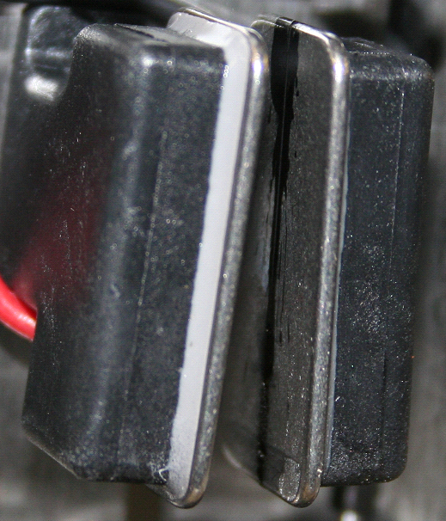

Figure : Deflector plates after running I-645TF for 5 minutes in the 5 OC chamber.

# I-649TF

In order to circumvent the printer issues at 5 OC, the water level has been reduced to 2 % and the isobutyl isobutyrate also reduced to 2 % to further improve the solubility of water in the system. In order to maintain the conductivity at a printable level the dye had to be increased to 12 %.

|  |  |  |
| --- | --- | --- |
| I-649TF | | |
| Material | **%** | **Function** |
| MEK | 59 | Main solvent |
| Isobutyl isobutyrate | 2 | Hydrophobic tailing solvent increasing water resistance |
| Water | 2 | Increases the amount of conductivity imparted by the dye and hydrolyses silane |
| Joncryl 682 | 24 | High acid number acrylic giving alkali washability |
| Dynasylan 1146 | 1 | Aminosilane oligomer which couples the ink to glass substrates |
| HBDL N36B | 12 | Solvent black 29 dye |

Table : I-649TF formulation details.

|  |  |
| --- | --- |
| Test | Number of rubs required to remove |
| Rub resistance on wet glass immediately after printing | 3 – 5 |
| Rub resistance 10 mins after printing on wet glass | 7 – 10 |
| Rub resistance 1 hour after printing on wet glass | >10 |
| Rub resistance 24 hours after printing on wet glass | >10 |
| Water Immersion resistance after printing on dry glass (1 hour) | >10 |
| Water Immersion resistance after printing on wet glass (1 hour) | >10 |
| Caustic wash removal | Removed immediately |

Table : I-649TF end user properties

|  |  |
| --- | --- |
| Advantages | Issues |
| Stable formulation (12 weeks)  Good printer operation at all temperatures (not 60 µm 64 kHz) | Initial wet glass adhesion weaker than 234BK  Dynasylan 1146 not on Swiss Ordnance List  High level of dye concerning from perspective of meeting conductivity specification during manufacture |

Table : I-649TF advantages and issues.

The glass adhesion of 649TF is unchanged from 645TF. This formulation had excellent printer performance using i-Tech machines at all test temperatures with 75 µm 64 kHz and 60 µm 85 kHz configurations, but could not achieve a modulation window with 60 µm 64 kHz due to the formation of macro satellites. This is acceptable due to the wide availability of the 60 µm 85 kHz drop generator.

One concern with the dye level of 12 % is that the conductivity begins to plateau at this level. If the ink requires dye additions during manufacture to bring it into the conductivity specification a relatively large amount may need to be added, bringing solubility concerns. This issue is addressed in a later piece of work looking at dye additions where it was found that adding MEK as well as dye further increased the conductivity. This is a result of the solvent negating the viscosity increase which is accompanied by the dye addition.

The main problem with I-649TF is the fact Dynasylan 1146 is not on the Swiss Ordnance List, with the implication of not being able to recommend the ink for use on food packaging. This information was found out late in development after much of the work had already been completed. As such, customers who print on PET as well as glass bottles may be unwilling to use the ink.

# I-654TF

I-654TF employs a straight swap between Dynasylan 1146 and Dynasylan TRIAMO, as the latter material is on the Swiss Ordnance List and therefore suitable for use in food packaging applications.

For this formulation the order of addition plays a role. If the Dynasylan TRIAMO is added before the HBDL N36B a precipitate is formed which cannot be filtered through a GF-B filter pad. If the dye is added first followed by the silane no filtration issues are observed. It is interesting that if the dye is added after the precipitate has already formed no filtration issues are observed which suggest the precipitate is re-solubilised. It is still recommended that the dye is added before the silane to avoid the precipitate formation altogether.

|  |  |  |
| --- | --- | --- |
| I-654TF | | |
| Material | **%** | **Function** |
| MEK | 59 | Main solvent |
| Isobutyl isobutyrate | 2 | Hydrophobic tailing solvent increasing water resistance |
| Water | 2 | Increases the amount of conductivity imparted by the dye and hydrolyses silane |
| Joncryl 682 | 24.75 | High acid number acrylic giving alkali washability |
| Dynasylan TRIAMO | 0.25 | Triamino functional trimethyoxysilane |
| HBDL N36B | 12 | Solvent black 29 dye |

Table : I-654TF formulation details.

|  |  |
| --- | --- |
| Test | Number of rubs required to remove |
| Rub resistance on wet glass immediately after printing | >10 |
| Rub resistance 10 mins after printing on wet glass | >10 |
| Rub resistance 1 hour after printing on wet glass | >10 |
| Rub resistance 24 hours after printing on wet glass | >10 |
| Water Immersion resistance after printing on dry glass (1 hour) | >10 |
| Water Immersion resistance after printing on wet glass (1 hour) | >10 |
| Caustic wash removal | Removed immediately |

Table : I-654TF end user properties.

|  |  |
| --- | --- |
| Advantages | Issues |
| Better wet glass adhesion than 649TF  All materials on Swiss Ordnance list  Good printer operation at all temperatures (not 60 µm 64 kHz) | At the time of this work, only 6 weeks ageing data (but was ongoing)  High level of dye concerning from perspective of meeting conductivity specification during manufacture |

Table : I-654TF advantages and issues.

The glass adhesion properties of I-654TF are improved over I-649TF and are more similar to I‑635TF. The same concern with the high dye level is present, and the printer performance is seemingly identical to I-649TF, with the same limitation of being inoperable with a 60 µm 64 kHz configuration, but works well with 60 µm 85 kHz and 75 µm 64 kHz.

At the time of this work only 6 weeks of ageing has been completed but there are no concerns so far. Given the near identical ageing profile to I-649TF which successfully completed 12 weeks of ageing, it was decided to progress I-654TF to scale up and system test to prepare for launch.

I-654TF meets the desired end user properties, in-printer reliability and regulatory requirements, so is the preferred formulation but I-649TF is considered a back-up in the event that the ageing stability test of I-654TF poses any problems.

# Appendices

## Ink management systems



Figure . Ink management system schematic for an i-tech/ultima printer

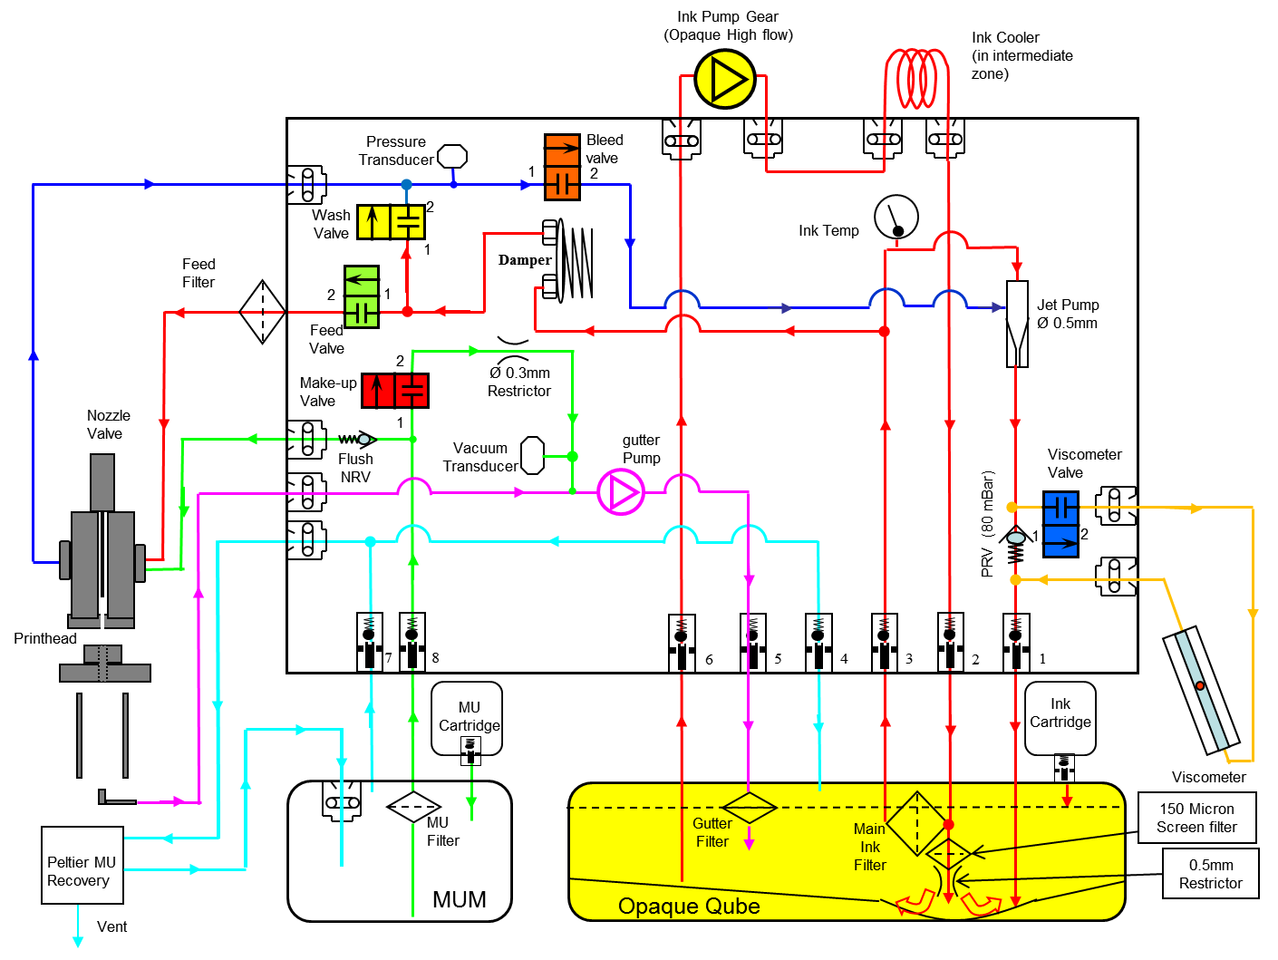

Figure . Ink management system schematic for an ‘opaque ink’ system Ax-series printer, differences to the non-opaque system are highlighted in yellow.

## Other training documents

### Theory of ink jet training module



### Viscosity Dependent Printhead Functions 2.0



# References

(1) Sweet, R. G. *High-Frequency Oscillography with Electrostatically Deflected Ink Jets*; Stanford, 1964.

(2) Le, H. P. *J. Imaging Sci. Technol.* **1998**, *42* (1), 49.

(3) Continuous Ink Jet technology explained https://www.youtube.com/watch?v=99Jz2JFmp1c.

(4) José-Yacamán, M.; Martín-Gil, J.; Ramos-Sánchez, M. C.; Martín-Gil, F. J. *J. Chem. Educ.* **2006**, *83* (10), 1476.

(5) Kyowa. http://www.face-kyowa.co.jp/english/en_science/en_theory/en_what_Surface_tension/ http://www.face-kyowa.co.jp/english/en_science/en_theory/en_what_Surface_tension/ (accessed Feb 4, 2016).

(6) Edgeworth, R.; Dalton, B. J.; Parnell, T. *Eur. J. Phys.* **1984**, *5* (4), 198.

(7) Reynolds, S. *Rheological techniques for low viscosity Domino fluids - Doc-0008305*.

(8) Bruce, C. A. *IBM J. Res. Dev.* **1976**, *20* (3), 258.

(9) Derby, B. *Annu. Rev. Mater. Res.* **2010**, *40* (1), 395.

(10) Clasen, C.; Phillips, P. M.; Palangetic, L.; Vermant, and J. *AIChE J.* **2012**, *58* (10), 3242.

(11) Lake, T.; Noble, A. *Ink Chemistry Document \\dps.local\group\Domino\RandD\Live\Functions\MarkingMaterials\Library\Ink Chemistry\Ink Chemistry_2nd draft_August 2015.doc*; 2015.

(12) Farn, R. J. *Chemistry and Technology of Surfactants*; Wiley-Blackwell, 2006.

(13) Shchukin, E.D., Pertsov, A.V., Amelina E.A. and Zelenev, A. S. *Colloid and Surface Chemistry*, 1st ed.; Mobius D. and Miller R., Ed.; Elsevier Science B.V.: Amsterdam, 2001.

(14) Israelachvili, J. N. *Intermolecular and Surface Forces: With Applications to Colloidal and Biological Systems*; Colloid Science Series; Academic Press, 1985.

(15) Salim, M.; Minamikawa, H.; Sugimura, A.; Hashim, R. *Med. Chem. Commun.* **2014**, *5* (11), 1602.

(16) Malvern Instruments. Estimation of critical coil concentration http://www.azonano.com/article.aspx?ArticleID=1226.

(17) Monroy, F.; Arriaga, L. R.; Langevin, D. *Phys. Chem. Chem. Phys.* **2012**, *14* (42), 14450.

(18) *IUPAC Compendium of Chemical Terminology*; Nič, M., Jirát, J., Košata, B., Jenkins, A., McNaught, A., Eds.; IUPAC: Research Triagle Park, NC, 2009.

(19) http://rimg.geoscienceworld.org/content/44/1/105/F11.large.jpg.

(20) https://en.wikipedia.org/wiki/Zeta_potential https://en.wikipedia.org/wiki/Zeta_potential (accessed Feb 17, 2016).

(21) Hertz, H. C.; Sven-Inge, S. Ink jet recorder. US3416153A, December 10, 1968.

1. Hertz also pioneered a jet dispersion technique, starting a couple of years after Sweet but producing concurrent work.21
2. Cdr. Chris Hadfield demonstrates the phenomenon of surface tension very well in this [video](https://www.youtube.com/watch?v=9jB7rOC5kG8), from the International Space Station.
3. ‘Make up’ is the fluid a printer uses to replenish solvent lost from the ink due to evaporation in the CIJ process to maintain consistent viscosity and performance of an ink.
4. Or more generally 1/frequency.
5. See Project Lacey final report and user manual, 40C.
6. This report, Doc-0009168, is in preparation where this section has been reproduced from.
7. This is why paint is stirred before use, French dressing is shaken before poured and pigment dispersions are generated in a mill.
8. van der Waal forces encompass three different types of interactions (Keesome, Debye and London forces) the relevant attractive force for particle attraction is the London dispersion force that is generated by instantaneously induced dipoles.
9. Remember, the force exerted on a body is the differential of the potential energy with respect to displacement. Thus the slope of the potential at a given displacement, gives the force exerted.
10. Doc-0004518 – Bulletin explaining the need for an additional head filter for 234BK high temperature 24/7 applications, November 2006.
11. Doc-0005764 – PSG: Call 29709 - 234BK Code not removed, N. Ihekwaba, March 2012.
12. Doc-0002544 – Investigation into the cause of I-234BK requiring large solvent additions during manufacture, March 2009.
13. Doc-0008586 – Technical report describing the development of black, yellow and white inks which adhere to dry and wet glass and are removable by caustic wash (project Frink), A. Kyriacou,

    January 2015.
14. Investigation of red, blue and green inks which are suitable for printing onto glass substrates and can be removed by caustic wash, A. Kyriacou, January 2016 – Agile Document number pending.